AI OLYMPIAD • GRADE 11 • AI BASICS WORKBOOK SERIES
MONTH 3 • UNIT 3
AI Applications
AI Powers Innovation
AI Across Industries
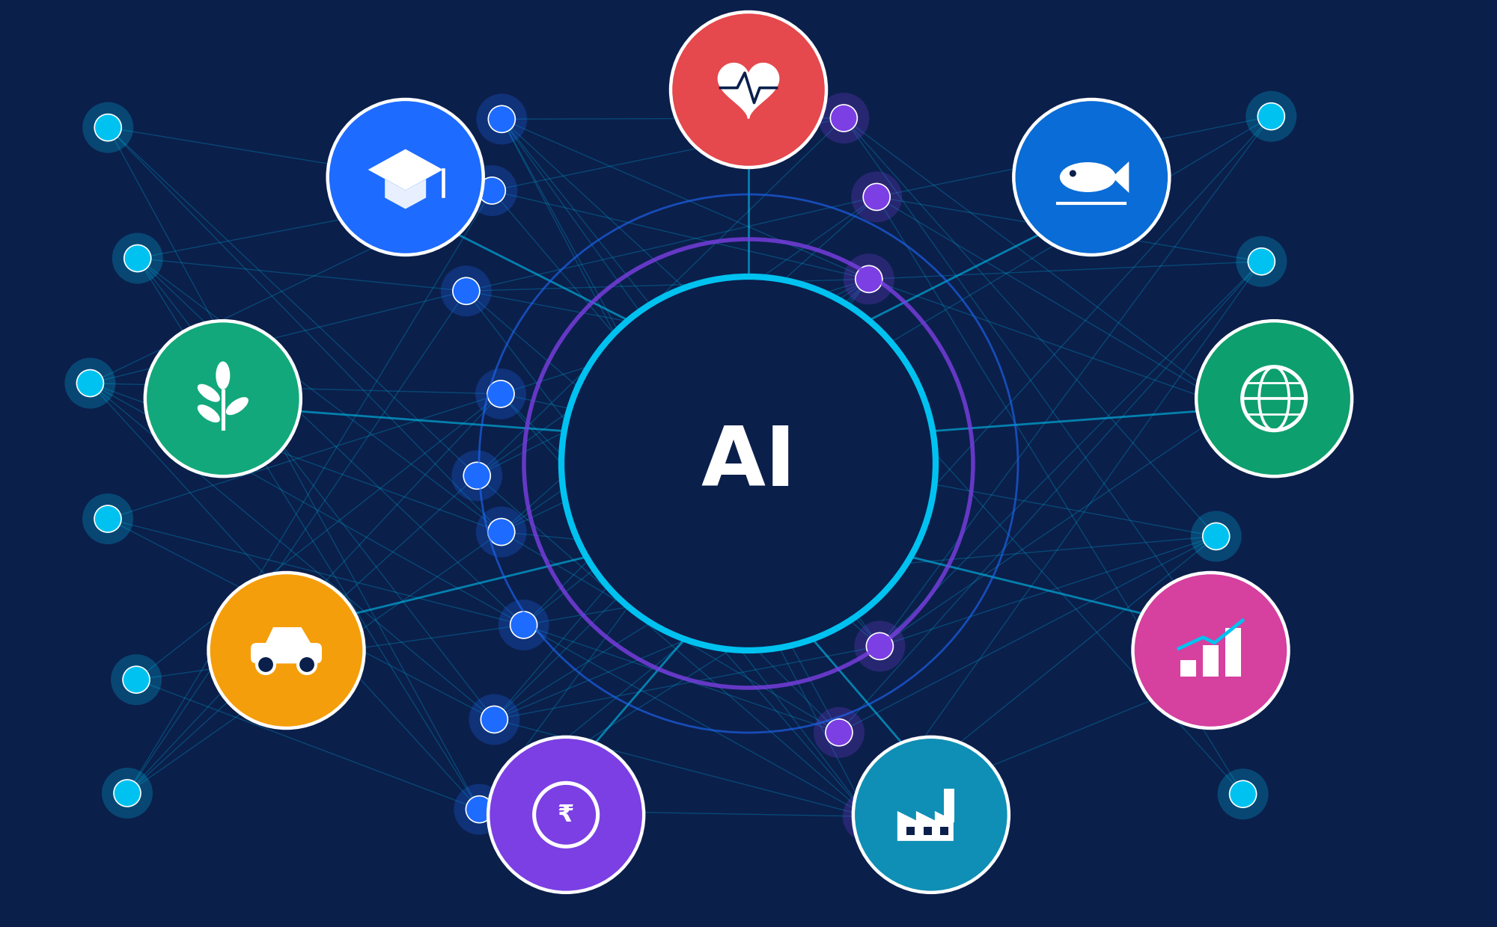
Healthcare • Education • Agriculture • Transportation • Banking
Manufacturing • Business • Environmental Protection • Marine Science
Student Workbook + Teacher Answer Key & Marking Schemes
Name: ______________________________ Class: ___________ Date: ______________

UNIT 3 • START HERE
Welcome to Unit 3
How AI turns data into new products, services and better decisions

Every day, AI quietly works behind the tools you use: the map app that predicts traffic, the bank that stops a suspicious payment, the streaming service that suggests your next show. In this unit you will look behind the screen. You will see how AI uses data, finds patterns, makes predictions, supports decisions and helps solve practical problems in nine industries, and you will learn to judge its benefits, limits and risks like a responsible innovator.

Learning outcomes
By the end of this unit, you will be able to:
- Explain how AI powers innovation using the six-step pipeline: data, patterns, prediction, decision, action, feedback.
- Describe real applications of AI in healthcare, education, agriculture, transportation, banking, manufacturing, business, environmental protection and marine science.
- Classify AI tasks (classification, forecasting, clustering, anomaly detection, recommendation, vision, language) used in industry.
- Evaluate benefits, limitations and challenges such as bias, privacy, reliability, cost and explainability.
- Apply responsible-AI principles and the human-in-the-loop idea to realistic situations.
- Distinguish verified real-world applications from hypothetical examples, and design your own AI solution brief.

How to use this workbook
Look for | What it means
✔ VERIFIED | A real application described in public sources (company, research or government publications). Details were checked at the time of writing. Technology changes quickly, so check current sources before quoting figures.
◆ HYPOTHETICAL | An invented but realistic example made up to explain an idea. Numbers in hypothetical examples and in "illustrative" diagrams are not real data.
THINK & DISCUSS | An open question for pair or class discussion. There is often more than one good answer.
KEY IDEA | The most important point of a section. Revise these first.
[2] | Marks for a question. Dotted lines are space for your answer.

KEY IDEA
AI is a tool, not a magic brain. It is only as good as its data, its design and the people who guide it.

CONTENTS
What is inside
Seven parts, one connected story

Part 1 | AI Powers Innovation  What innovation is, the AI pipeline, AI task types, rule-based software vs machine learning, human-in-the-loop
Part 2 | AI Across Industries  Nine industry chapters: healthcare, education, agriculture, transportation, banking, manufacturing, business, environmental protection, marine science
Part 3 | Benefits, Limits & Responsible AI  Benefits and limitations, key challenges, responsible-AI principles and a decision checklist
Part 4 | Practice & Activities  Three worksheets, 30 MCQs, five classroom activities, four puzzles, quick quiz
Part 5 | Apply & Assess  Two real-life case studies, mini-project, 30-mark chapter assessment
Part 6 | Review  Chapter summary, concept map, revision exercises, glossary
Part 7 | Teacher Edition  Complete answer keys with explanations and marking schemes

Suggested study plan (two weeks)
When | Study | Output
Days 1–2 | Part 1: pipeline, task types, human-in-the-loop | Worksheet 1 (Q1–4) and Activity 1
Days 3–7 | Part 2: nine industry chapters (about two per day) | Worksheets 1–3, Activity 2, Puzzle 1
Days 8–9 | Part 3: benefits, limits, challenges, responsible AI | Activities 3–4, MCQs 1–30
Days 10–11 | Case studies and mini-project | Case-study answers, project brief
Days 12–14 | Revision: summary, concept map, glossary | Quick quiz, 30-mark assessment

SCOPE OF THIS BOOK
This workbook covers Unit 3 only (AI Applications: AI Powers Innovation; AI Across Industries). Ideas from other units, such as how algorithms are trained in detail, are mentioned only as far as needed to understand applications.

 | PART 1  AI Powers Innovation  From raw data to new ideas that create value

1.1 What is innovation, and where does AI fit?
Innovation means turning a new or improved idea into something people can actually use: a better product, a cheaper service, a faster process. The electric motor, the internet and the smartphone were not just inventions; each triggered waves of innovation in many industries. Experts often call AI a general-purpose technology for the same reason: once the basic capability exists, it can be applied almost everywhere there is data.
AI powers innovation in six main ways. Notice that each one starts from the same raw material: data.
AI strength | What it means | Quick example
Speed & scale | Checks millions of records or images in seconds | A bank scores every card payment before approving it
Pattern finding | Spots links people would miss in huge data sets | Satellite images reveal where forest is being cleared
Prediction | Estimates what is likely to happen next | A maps app predicts your arrival time
Personalisation | Adapts to each user | A learning app picks the next question for you
Early warning | Detects small changes before they become big problems | A sensor pattern warns that a machine may fail
Discovery | Helps scientists explore possibilities faster | AI predicts 3-D shapes of proteins to support biology research

1.2 The AI innovation pipeline
Whether an AI system helps a doctor, a farmer or a banker, it usually follows the same six-step pipeline. Learn this pipeline well; you will use it again and again in this unit.
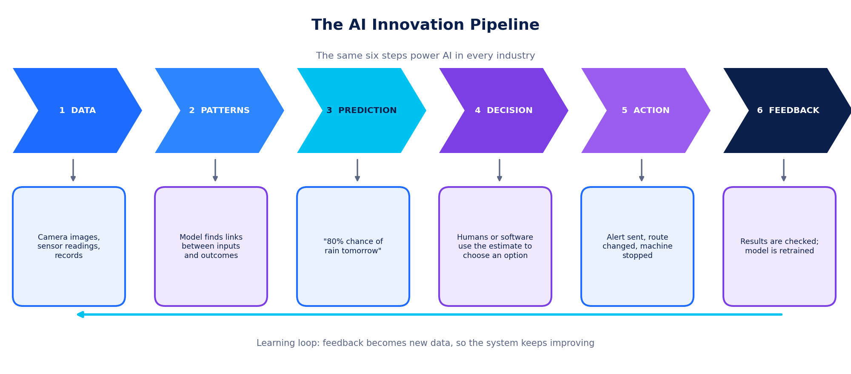
Figure 1.1: The six-step AI innovation pipeline. Feedback becomes new data, so the loop repeats.
Step | Explanation with a weather-app example
1 Data | Facts collected as numbers, images, sound or text. Example: temperature, humidity and wind readings from thousands of stations and satellites.
2 Patterns | A model learns relationships between inputs and outcomes. Example: it learns that falling pressure plus rising humidity often comes before rain.
3 Prediction | The model estimates something unknown. Example: “80% chance of rain at 5 p.m.” A prediction is an estimate, not a certainty.
4 Decision | A person or software chooses what to do with the estimate. Example: you decide to carry an umbrella; a city decides to open flood gates.
5 Action | The decision is carried out in the real world. Example: an alert is sent to phones; a farmer delays spraying.
6 Feedback | Results are compared with what really happened, and the model is improved. Example: forecast errors are recorded and used to retrain.

KEY IDEA
A prediction is not a decision. AI produces an estimate such as “82% chance this payment is fraud”. People or rules then decide what to do: approve, ask for an OTP, or block.

1.3 Types of AI tasks used in industry
Different industries use the same few kinds of AI task. Once you can name the task, you can understand almost any application.
Task type | What it does | Examples in this unit
Classification | Puts an item into a category | Scan shows disease or no disease; email is spam or not spam; leaf has blight or is healthy
Forecasting (regression) | Predicts a number | Tomorrow’s rainfall; next week’s sales; arrival time of a bus
Clustering | Groups similar items without pre-set labels | Grouping customers with similar buying habits
Anomaly detection | Finds what is unusual | Strange card payment; machine vibration that drifts from normal
Recommendation | Suggests items you may like or need | Video or product suggestions; next practice question
Computer vision | Understands images and video | Reading retina photos; spotting weeds; counting fish; mapping reefs
Speech & language (NLP) | Understands or produces speech and text | Live captions; banking chatbots; translation; AI tutors
Optimisation & planning | Finds the best option under limits | Delivery routes; bus schedules; energy use in a factory

1.4 Rule-based software vs machine learning
Traditional software follows rules that people write. Machine learning (ML), the most common kind of AI in industry, learns its rules from examples. ML is a part of AI, and deep learning (neural networks with many layers) is a part of ML. Deep learning powers most image, speech and language systems you meet today.
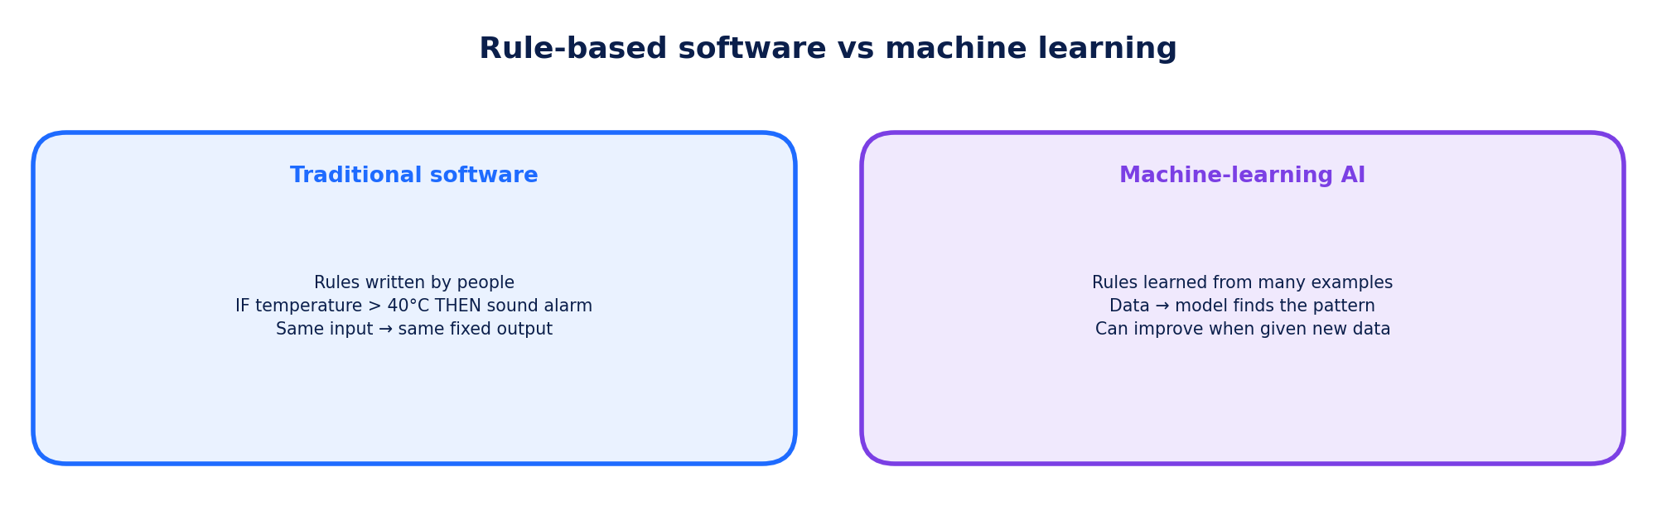
Figure 1.2: Fixed rules vs rules learned from data.
THINK & DISCUSS
A thermostat that switches on a fan above 30°C is rule-based. A system that learns, from months of sensor data, that a particular pump usually fails after its vibration pattern changes is machine learning. Which one is easier to explain? Which one can handle situations no programmer thought of?

1.5 Humans stay in the loop
In serious fields such as medicine, banking or transport, AI is usually designed as an assistant. The AI suggests; a trained person checks and decides. This design is called human-in-the-loop. How much human control is needed depends on the stakes (how bad could a mistake be?) and reversibility (can the mistake be undone?). A spelling suggestion needs no review, but a medical diagnosis or a loan rejection does.
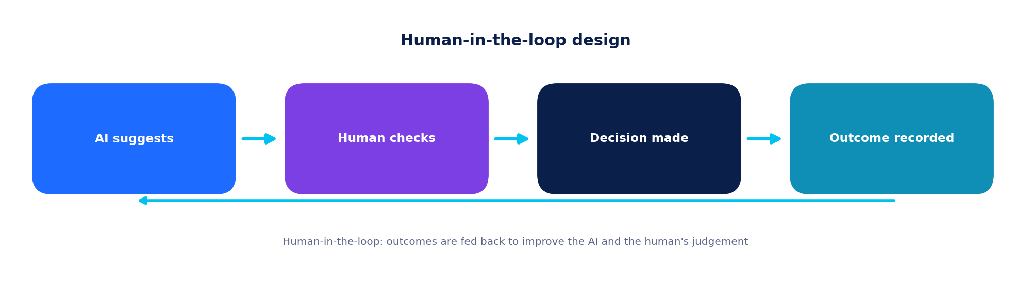
Figure 1.3: Human-in-the-loop design keeps people responsible for important decisions.
VERIFIED vs HYPOTHETICAL: A QUICK SKILL
When you read about an AI application, ask: Who built it? Where was it reported? Can I find the source? If you can, it is likely verified. If the story is invented to explain an idea, it is hypothetical, and that is fine as long as it is clearly labelled. In this workbook every example is labelled.

 | PART 2  AI Across Industries  Nine fields, one pipeline

Now that you know the pipeline, see how it appears in real industries. The map below shows the nine industries studied in this unit and one typical use in each.
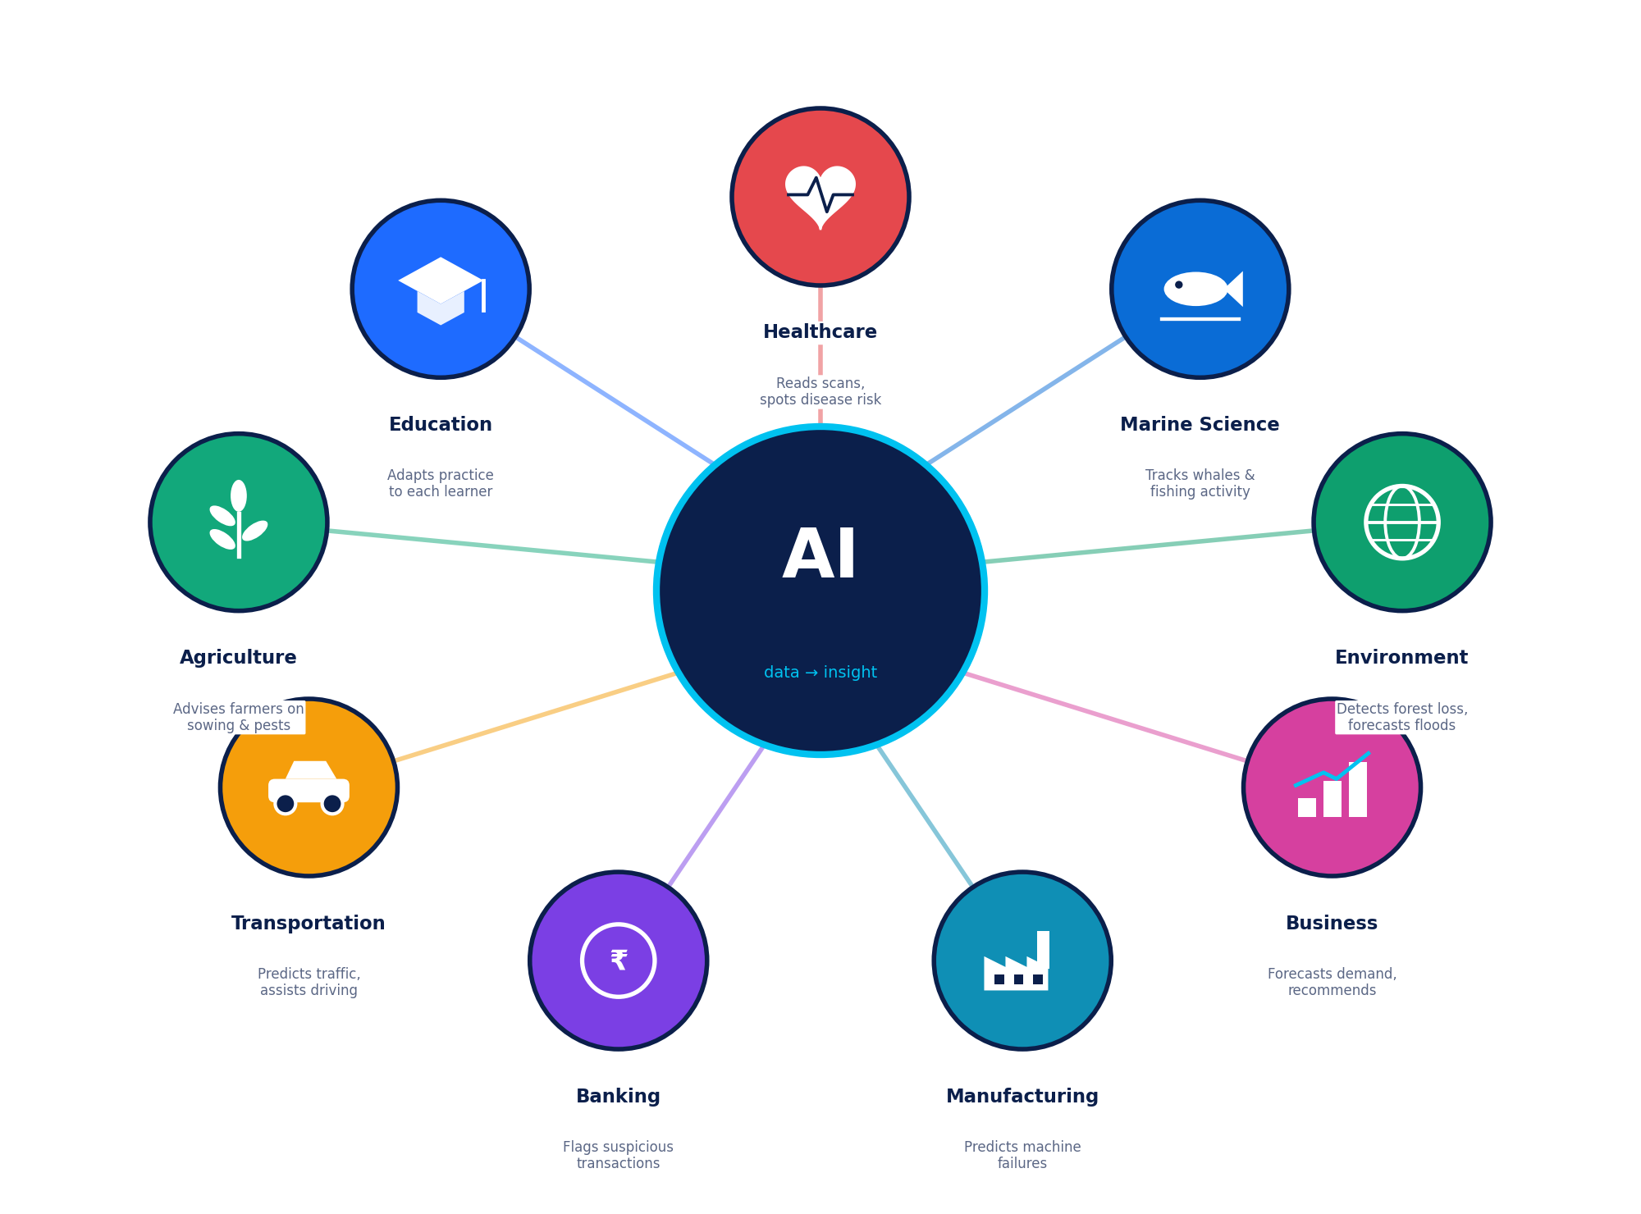
Figure 2.0: Nine industries, one AI core: data turned into insight.
Industry | Typical data | Typical AI task | Example (verified)
Healthcare | Scans, signals, records | Classification | IDx-DR; AlphaFold database
Education | Answers, time, speech | Recommendation, NLP | Duolingo; Khanmigo
Agriculture | Weather, soil, images | Forecasting, vision | ICRISAT sowing advice; Nuru
Transportation | GPS, sensors, cameras | Forecasting, vision | Maps ETA; Waymo
Banking | Transactions, history | Anomaly detection | Bank chatbots; card fraud scoring
Manufacturing | Machine sensors, images | Anomaly detection, vision | Predictive maintenance
Business | Sales, clicks, messages | Recommendation, forecasting | Netflix; Amazon
Environment | Satellites, sensors | Vision, forecasting | Global Forest Watch; flood alerts
Marine science | AIS, images, sound | Vision, anomaly detection | Global Fishing Watch; Allen Coral Atlas

HOW EACH INDUSTRY CHAPTER IS ORGANISED
Each chapter has: Why AI here? • The pipeline in that industry • a labelled diagram • verified applications • one hypothetical example • benefits and limitations • a Think & Discuss question.

 | INDUSTRY 1 OF 9  Healthcare  A second pair of eyes for doctors, and faster science.

Why AI here?
Hospitals and clinics produce huge amounts of data: X-rays, CT and MRI scans, retina photographs, ECG signals, lab results and doctors’ notes. AI, especially computer vision, learns from thousands of scans that experts have labelled, so it can highlight the regions that deserve attention. AI does not replace the doctor. It helps with screening (checking many people quickly), triage (deciding who needs help first) and planning.
AI also supports research. Proteins fold into complex 3-D shapes that decide what they do in the body, and working out these shapes by experiment can take months or years. AI models that predict protein shapes help scientists study diseases and design medicines faster.

The AI pipeline in healthcare
Stage | What happens
Data | Retina photos, chest X-rays, ECG traces, health records (stored securely and, where possible, with names removed).
Patterns | A neural network learns visual features linked to disease from many labelled images.
Prediction | For a new scan it outputs a probability, for example “60% chance of referable disease”.
Decision & action | A clinician reviews the result, orders tests or refers the patient. The outcome is recorded to check the AI’s accuracy.
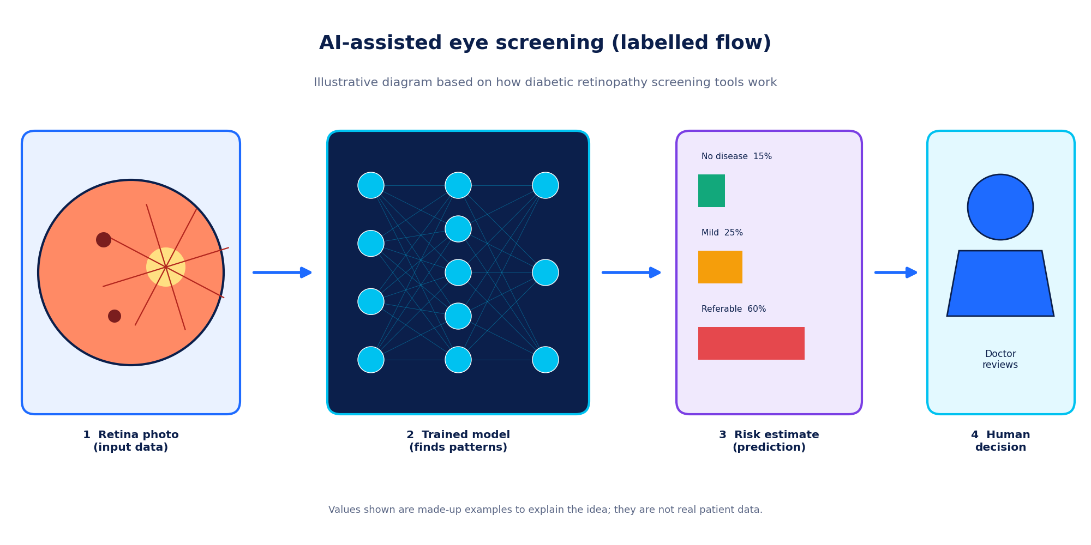
Figure 2.1: Labelled flow of AI-assisted eye screening (illustrative diagram; values are made up).

Real-world applications
✔ VERIFIED REAL-WORLD APPLICATION • Diabetic retinopathy screening (IDx-DR)
In 2018 the US Food and Drug Administration (FDA) authorised IDx-DR, described as the first autonomous AI diagnostic system, to detect more than mild diabetic retinopathy from retina images in primary-care settings. The device gives a result about whether the patient should be referred to an eye specialist.

✔ VERIFIED REAL-WORLD APPLICATION • AlphaFold protein structures
DeepMind’s AlphaFold 2 reached a major breakthrough in accuracy at the CASP14 protein-structure competition in 2020. In 2021–22, DeepMind and EMBL’s European Bioinformatics Institute made predicted structures freely available in the AlphaFold Protein Structure Database, which grew to more than 200 million proteins.

◆ HYPOTHETICAL EXAMPLE (created for learning) • Ward early-warning dashboard
Imagine a hospital system that combines heart rate, oxygen level and blood pressure trends and gives each patient a “deterioration risk” score every hour. When a score crosses a limit, a nurse receives an alert and checks the patient. (This is an invented example to show the pipeline; it is not a named product.)

✔ Benefits  - Faster screening of large numbers of patients  - Consistent reading of images, even late at night  - Extends specialist skills to remote clinics  - Speeds up medical research | ⚠ Limitations & challenges  - Needs large, high-quality, correctly labelled data  - May perform worse for groups missing from the training data  - Health data is highly private and must be protected  - Errors can be serious, so doctors stay accountable  - Tools must be tested and approved by regulators

THINK & DISCUSS
If an AI system and a doctor disagree about a scan, who should make the final decision, and what should happen next? What would make you trust the result?

 | INDUSTRY 2 OF 9  Education  Practice that adapts to every learner.

Why AI here?
Every student learns at a different speed. Educational AI uses data such as which answers were right or wrong, how long a student took and which topics are repeated, to estimate what the learner already knows and to choose what to practise next. This is called adaptive learning. Teachers also use AI to prepare practice material, to see which topics the whole class finds hard, and to reduce paperwork.
Language AI adds more tools: live captions and translation for students who are deaf or learning a new language, text-to-speech for readers who need support, writing feedback and AI tutors that explain a concept step by step. These tools can also make mistakes, so students need to check answers and keep thinking for themselves.

The AI pipeline in education
Stage | What happens
Data | Answers, time taken, hints used, topics revisited, spoken or written practice.
Patterns | A model estimates mastery of each topic and how hard each question is.
Prediction | It predicts which question will be challenging but achievable, and when a learner is likely to forget a word.
Decision & action | The app selects the next task and shows feedback. Teachers see class dashboards and decide how to teach next.
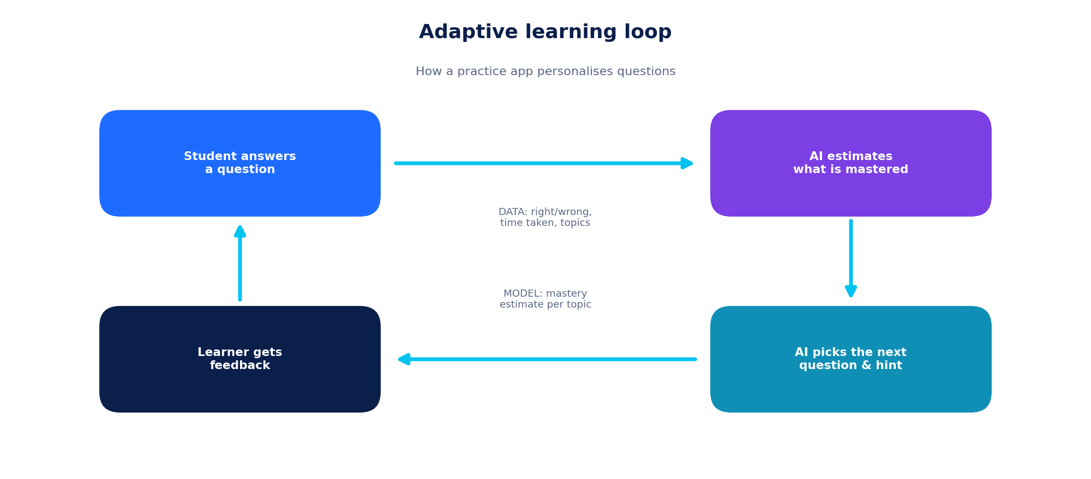
Figure 2.2: The adaptive learning loop used by many practice apps.

Real-world applications
✔ VERIFIED REAL-WORLD APPLICATION • Duolingo and personalised practice
Duolingo has published descriptions of a machine-learning system, called Birdbrain, that estimates how well each learner knows material and how hard each exercise is, and uses these estimates to choose exercises.

✔ VERIFIED REAL-WORLD APPLICATION • Khanmigo AI tutor (Khan Academy)
In 2023 Khan Academy began piloting Khanmigo, an AI tutor and teaching assistant built on a large language model. It is designed to guide students with questions and hints rather than simply give answers, and to help teachers with planning.

◆ HYPOTHETICAL EXAMPLE (created for learning) • StudyPal mistake-pattern coach
Imagine a physics app that notices a student often answers “speed” when the question asks for “velocity”. It offers five targeted questions on direction and shows the teacher a note: “6 of 30 students confuse speed and velocity.” (Invented example.)

✔ Benefits  - Learning pace matches each student  - Instant feedback outside class time  - Teachers see problem topics sooner  - Accessibility tools (captions, read-aloud, translation) | ⚠ Limitations & challenges  - Chatbots can give confident but wrong answers  - Student data needs strong privacy protection  - Over-reliance can weaken thinking and writing skills  - Unequal access to devices and internet  - Automatic marking can be biased or miss creativity

THINK & DISCUSS
Describe one way you could use an AI tutor so that it makes you think more, not less. What rule would you follow before trusting an AI-generated answer?

 | INDUSTRY 3 OF 9  Agriculture  The right input, in the right place, at the right time.

Why AI here?
Farming depends on weather, soil, water, pests and market prices, and all of them are uncertain. AI turns data from satellites, drones, soil sensors, weather stations and phone photos into practical advice: when to sow, how much to irrigate, which disease a leaf has and where to spray. Using inputs only where and when needed is called precision agriculture.
Because many farmers have simple phones, some of the most useful systems send short advice by SMS, voice message or a light mobile app, sometimes working offline and in local languages.

The AI pipeline in agriculture
Stage | What happens
Data | Rainfall history, weather forecasts, soil-moisture readings, satellite and drone images, leaf photos.
Patterns | Models learn how rainfall, soil and crop stage relate to yield, pests and disease.
Prediction | Predicts a good sowing window, irrigation need, disease type or weed location.
Decision & action | Farmer receives advice (SMS, app, voice); machines such as sprayers can act on weed maps. Results are recorded for next season.
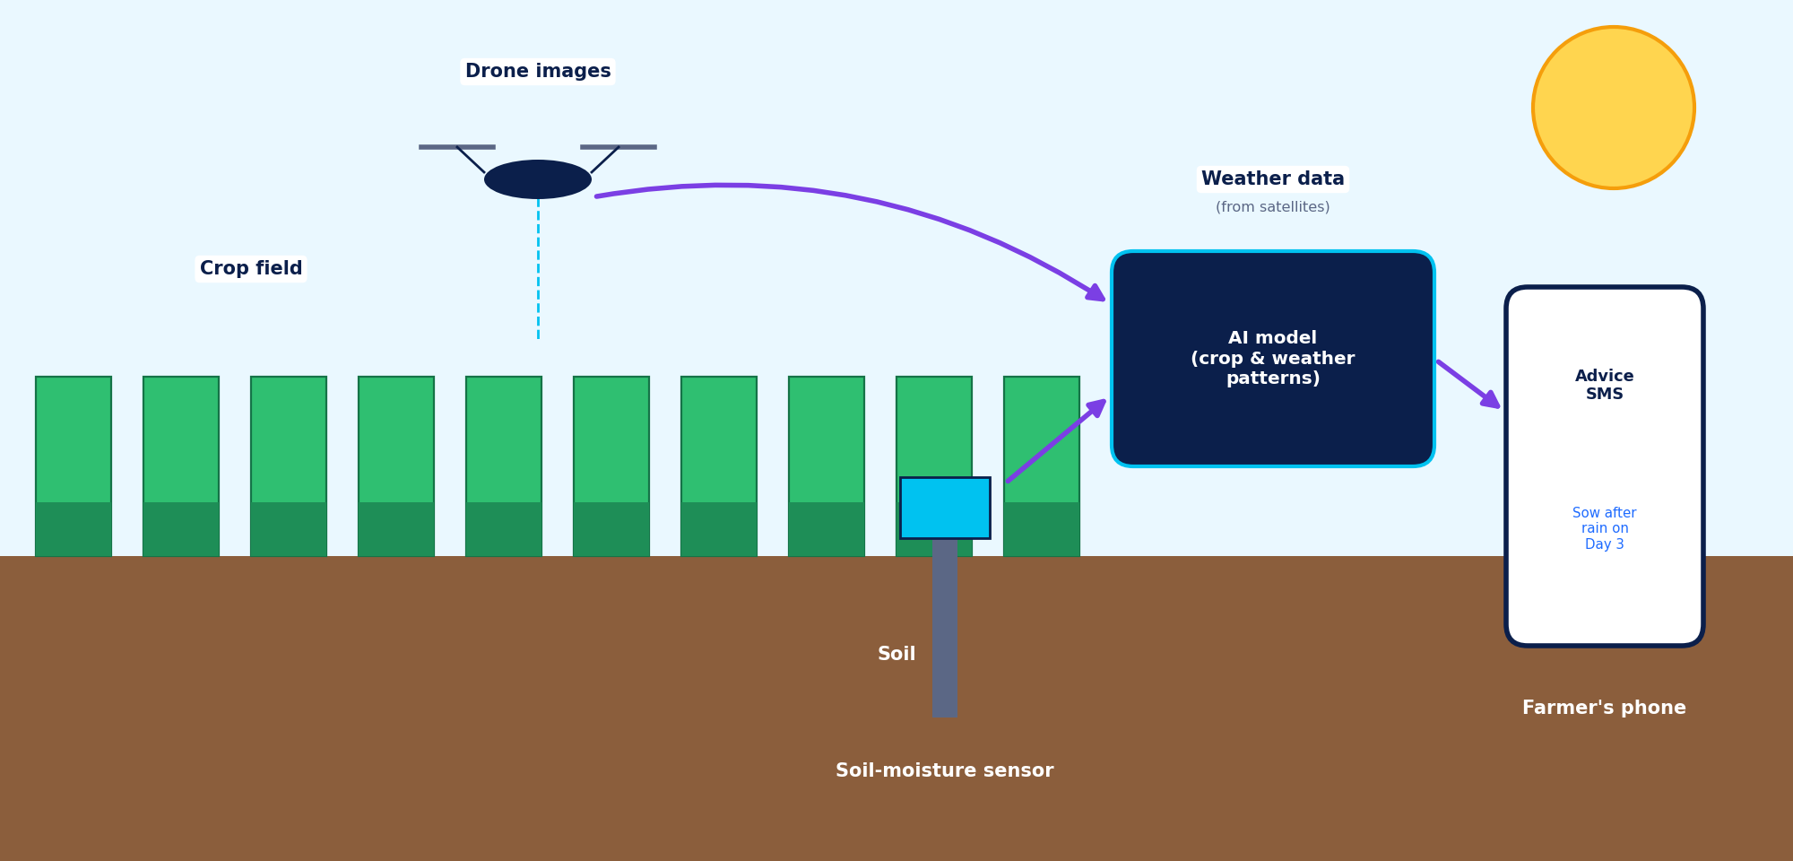
Figure 2.3: Labelled diagram of data sources and advice flow in AI-supported farming (illustrative).

Real-world applications
✔ VERIFIED REAL-WORLD APPLICATION • AI sowing advice for groundnut farmers (ICRISAT and Microsoft)
In 2016 the research institute ICRISAT and Microsoft piloted an AI-based sowing advisory with farmers in Andhra Pradesh, India. The system used weather data and historical records to suggest sowing dates, which were sent to farmers as text messages in the local language. The project reported better yields for farmers who followed the advice.

✔ VERIFIED REAL-WORLD APPLICATION • Nuru app for cassava disease (PlantVillage)
Researchers at Penn State and partners including the Food and Agriculture Organization of the UN developed Nuru, an AI app that helps farmers diagnose cassava diseases from phone-camera images and can work without an internet connection.

✔ VERIFIED REAL-WORLD APPLICATION • See & Spray (Blue River Technology, John Deere)
Camera-guided sprayers use machine learning to tell crop plants from weeds and spray only the weeds, which can reduce the amount of herbicide used.

◆ HYPOTHETICAL EXAMPLE (created for learning) • Drip-irrigation planner for a village cooperative
Imagine a cooperative that combines soil-moisture sensors with a rainfall forecast. If rain is likely tomorrow, the AI advises postponing irrigation and sends a voice message in the local language to each member. (Invented example.)

✔ Benefits  - Saves water, fertiliser and pesticide  - Reduces crop losses with early disease detection  - Advice in local languages and on simple phones  - Better planning against weather risk | ⚠ Limitations & challenges  - Sensors and drones cost money  - Weak mobile networks in remote areas  - A model trained for one region or crop may not suit another  - Questions about who owns farmers’ data  - Farmers need trust, training and extension-worker support

THINK & DISCUSS
Why might an app trained on cassava leaves in one country fail on rice leaves in another? What data would you collect to fix this?

 | INDUSTRY 4 OF 9  Transportation  Safer, smoother and smarter journeys.

Why AI here?
Transport generates a lot of data: GPS signals from phones, road cameras, traffic sensors, ticketing records and vehicle sensors. AI uses it to predict travel time, suggest routes, plan public-transport schedules, manage traffic signals and keep aircraft, trains and buses in good condition through predictive maintenance. Logistics companies also use AI to plan delivery routes.
In driver-assistance and self-driving systems, AI interprets sensor data and helps control the vehicle. Driving automation is described in levels: in driver-assistance (Level 2) the human must supervise at all times, while in Level 4 services the vehicle drives itself within limited areas and conditions. Today, fully driverless operation exists only in restricted settings.

The AI pipeline in transportation
Stage | What happens
Data | Camera images, radar and lidar readings, GPS location, maps, traffic and weather feeds.
Patterns | Neural networks learn to recognise lanes, signs, vehicles and pedestrians, and to model typical traffic flow.
Prediction | Predicts what nearby road users will do next, or how long a journey will take.
Decision & action | Plans a safe path and controls steering and braking, or suggests a route to the user. Safety limits and human backup stay in place.
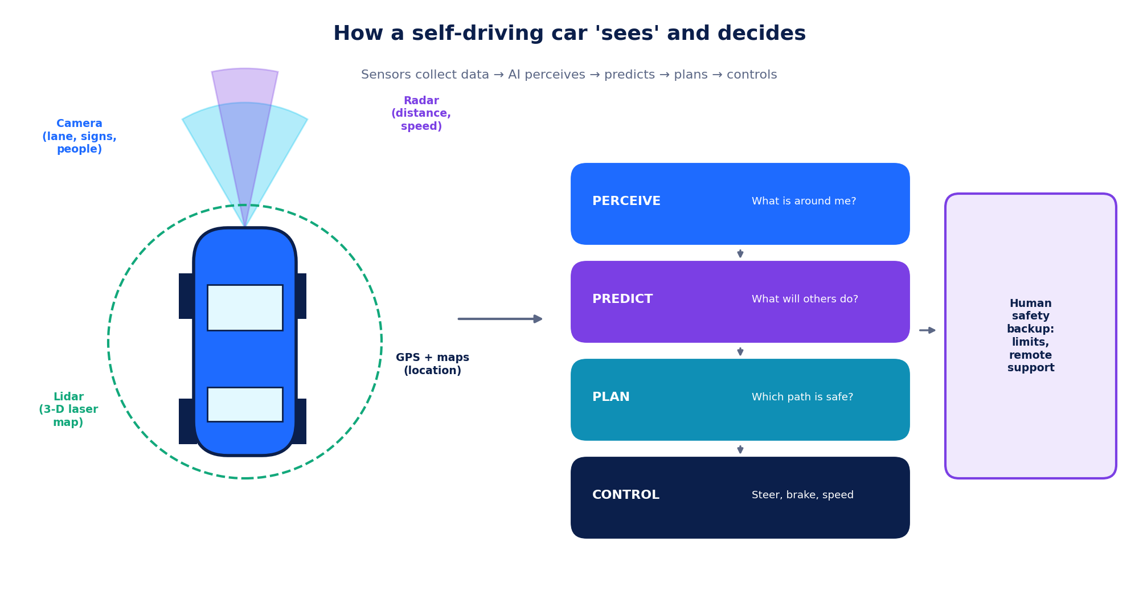
Figure 2.4: Sensors and decision stages of a self-driving system (simplified, illustrative).

Real-world applications
✔ VERIFIED REAL-WORLD APPLICATION • Better arrival-time estimates in Google Maps
In 2020, Google and DeepMind reported that a graph neural network, which treats the road network as connected segments, improved the accuracy of estimated arrival times in several large cities.

✔ VERIFIED REAL-WORLD APPLICATION • Waymo driverless ride service
Waymo, a self-driving company, operates a ride-hailing service without a human driver in some US cities, within areas it has mapped and tested. Service areas and rules change over time, so check its current website for details.

◆ HYPOTHETICAL EXAMPLE (created for learning) • Bus crowding forecaster
Imagine a city bus authority that predicts, from past ticket data, weather and local events, which routes will be crowded at 8 a.m. tomorrow, and sends extra buses to those routes. (Invented example.)

✔ Benefits  - Shorter, more predictable journeys  - Potential to reduce human-error accidents  - Less fuel use and congestion  - Fewer breakdowns through early maintenance | ⚠ Limitations & challenges  - Rare, unusual road situations are hard to learn  - Bad weather and faded road markings reduce sensor quality  - Legal and ethical questions about responsibility after a crash  - Connected vehicles need strong cyber-security  - High cost of mapping and infrastructure

THINK & DISCUSS
A driverless vehicle meets a situation its designers did not expect. Who should decide the safety rules: engineers, companies, governments or the public? Why?

 | INDUSTRY 5 OF 9  Banking & Finance  Protecting money in milliseconds.

Why AI here?
Banks process millions of transactions every day, which makes them natural users of AI. The best-known use is fraud detection: each payment is compared with the customer’s normal behaviour and with known fraud patterns, and given a risk score. Banks also use AI for credit scoring (estimating the chance a loan will be repaid), chatbots, monitoring for money-laundering, reading forms and documents, and personalised offers.
Money decisions affect people’s lives, so banks and regulators expect AI decisions to be fair, explainable and open to appeal. A customer who is refused a loan should be able to know why and ask for a human review.

The AI pipeline in banking
Stage | What happens
Data | Transaction amount, place, time, device, past spending habits, repayment history.
Patterns | The model learns what normal and suspicious activity look like across millions of past cases.
Prediction | Outputs a risk score such as 0–100 for each payment or loan application.
Decision & action | Low risk: approve. Medium: ask for an OTP or call the customer. High: block and alert. Analysts review difficult cases.
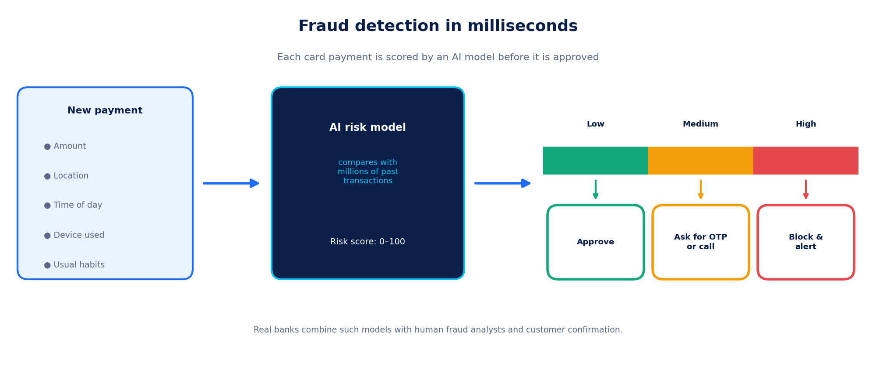
Figure 2.5: Scoring a payment for fraud risk before approving it (illustrative).

Real-world applications
✔ VERIFIED REAL-WORLD APPLICATION • Bank chatbots in India (HDFC Bank EVA and SBI SIA)
HDFC Bank introduced the EVA virtual assistant in 2017 and State Bank of India introduced the SBI Intelligent Assistant (SIA); both use language AI to answer customer questions about products and services.

✔ VERIFIED REAL-WORLD APPLICATION • Card-payment fraud scoring
Major card networks such as Visa and Mastercard have publicly described using AI-based systems to score card transactions for fraud risk in real time.

◆ HYPOTHETICAL EXAMPLE (created for learning) • Mule-account spotter
Imagine a small bank whose AI flags an account that suddenly receives many small deposits and sends the money onward within minutes. The case is sent to a human analyst, who decides whether to freeze the account. (Invented example.)

✔ Benefits  - Catches fraud quickly, often before money leaves  - Customer help available around the clock  - Faster loan decisions and less paperwork  - Can monitor patterns too large for people to check | ⚠ Limitations & challenges  - False alarms may block genuine payments  - Credit models can be unfair if past data was unfair  - Customer financial data is very sensitive  - Some models are hard to explain to customers and regulators  - Criminals change tactics, so models must be updated

THINK & DISCUSS
If an AI system rejects a loan application, what explanation should the customer receive? What rights should they have?

 | INDUSTRY 6 OF 9  Manufacturing  Factories that predict, inspect and adapt.

Why AI here?
Modern factories place sensors on machines to measure vibration, temperature, electric current and sound, and use cameras along the production line. AI uses this data for predictive maintenance (repairing a machine just before it fails), visual quality inspection (finding tiny defects faster than the human eye), robot guidance, energy saving and production planning.
Engineers also build digital twins: virtual copies of a machine or whole plant that are updated with real sensor data. Teams can test changes on the twin first, which is cheaper and safer than experimenting on the real factory.

The AI pipeline in manufacturing
Stage | What happens
Data | Vibration, temperature, current and sound from machines; camera images of products; maintenance logs.
Patterns | The model learns what normal operation looks like and what defects look like.
Prediction | Predicts remaining healthy time of a part, or the probability that a product is defective.
Decision & action | Maintenance is scheduled; faulty items are removed; the line is adjusted. Results update the model.
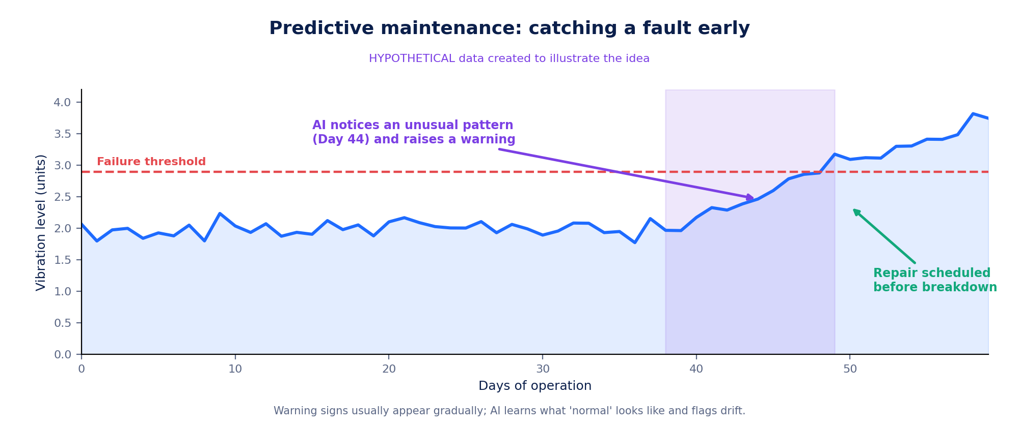
Figure 2.6: Predictive maintenance, catching a fault before breakdown (hypothetical illustrative data).

Real-world applications
✔ VERIFIED REAL-WORLD APPLICATION • AI for maintenance and quality inspection in industry
Industrial companies such as Siemens and BMW Group have publicly described using AI in their own plants, for example for visual quality inspection and for predicting when equipment needs service. Details differ by plant and change as systems are updated.

◆ HYPOTHETICAL EXAMPLE (created for learning) • Bottle-inspection camera
Imagine a drinks plant where a camera photographs every bottle on a fast conveyor. An AI model flags cracks and fill-level errors, and an air jet removes faulty bottles. Staff review the rejected bottles each hour to check the AI is not rejecting good ones. (Invented example.)

✔ Benefits  - Fewer unexpected breakdowns and less downtime  - Consistent inspection, even at high speed  - Less waste and energy use  - Robots can take over dangerous tasks | ⚠ Limitations & challenges  - Needs sensors and enough history for each machine type  - Older machines may have no digital data  - False alarms waste time; missed alarms are costly  - Workers need new skills; some roles change  - Connected machines must be protected from cyber-attacks

THINK & DISCUSS
Which factory jobs will change because of AI, and which new skills will workers need? How could a company support its staff through the change?

INDUSTRY 7 OF 9
Business
Know your customers, plan your stock.

Why AI here?
Businesses collect data on sales, stock, website visits, deliveries and customer questions. AI uses it for recommendation engines, demand forecasting, supply-chain planning, price optimisation, customer-support chatbots, marketing analysis and summarising documents. Good forecasts help a shop avoid both empty shelves and unsold goods.
A useful forecast shows its uncertainty, for example “120 units, probably between 105 and 135”. Managers can then plan for a range of outcomes instead of trusting a single number.

The AI pipeline in business
Stage | What happens
Data | Past sales, prices, holidays, weather, website clicks, customer messages.
Patterns | Models learn seasonal effects and which items are bought or viewed together.
Prediction | Forecasts demand for each product and predicts which items a customer may like.
Decision & action | Managers order stock; the website shows suggestions; chatbots handle routine questions and pass difficult ones to staff.
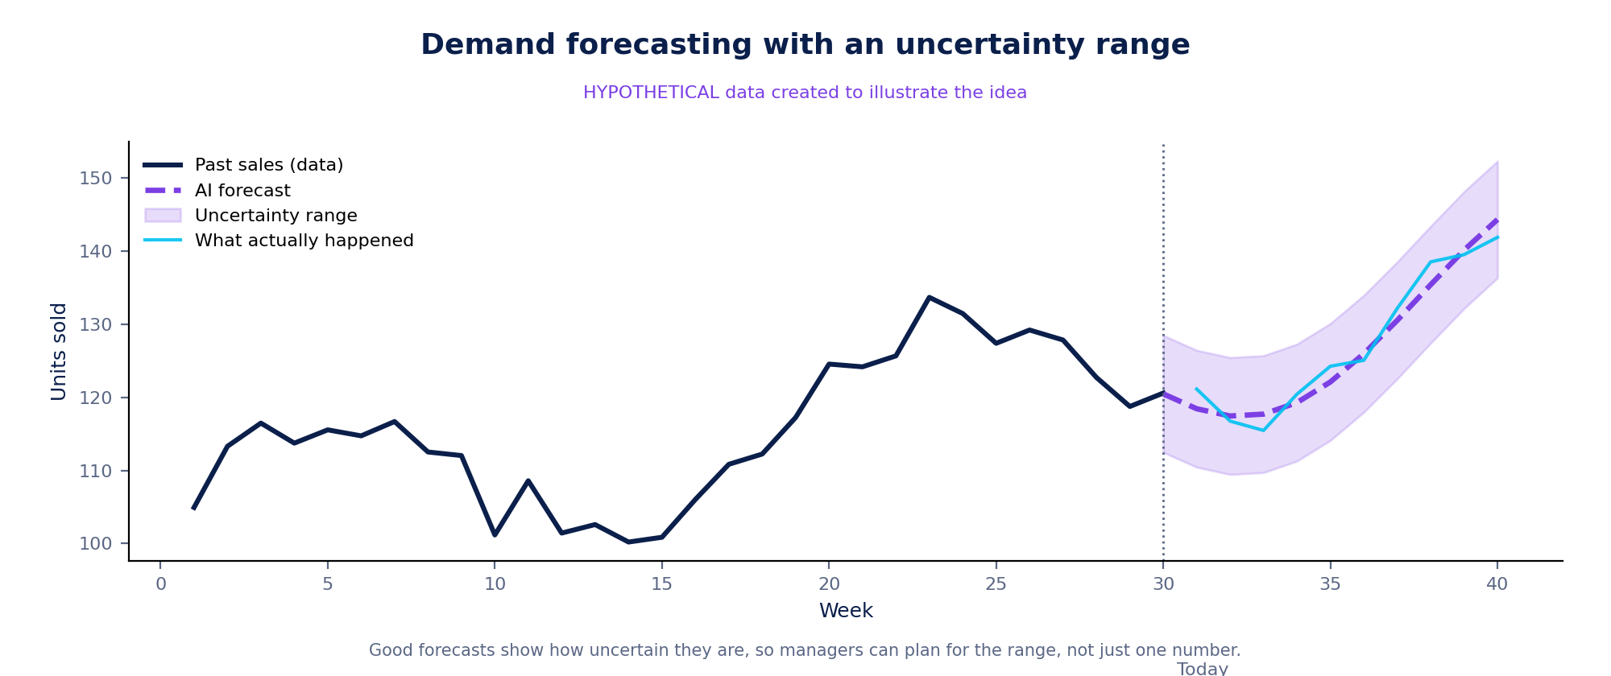
Figure 2.7: A demand forecast with an uncertainty range (hypothetical illustrative data).

Real-world applications
✔ VERIFIED REAL-WORLD APPLICATION • Netflix recommendations
Netflix researchers have published descriptions of its recommendation system, which personalises the titles and rows shown to each member, and have reported that most viewing comes through recommendations.

✔ VERIFIED REAL-WORLD APPLICATION • Amazon product recommendations and forecasting
Amazon published an influential method, item-to-item collaborative filtering, for suggesting products based on what customers buy together, and has described using machine learning for demand forecasting.

◆ HYPOTHETICAL EXAMPLE (created for learning) • Bakery loaf forecaster
Imagine a bakery chain whose AI uses past sales, weather and holiday dates to forecast how many loaves each outlet needs tomorrow, to reduce unsold bread. (Invented example; a worked example appears in Worksheet 2.)

✔ Benefits  - Less waste and fewer stock-outs  - More relevant suggestions for customers  - Faster replies to routine questions  - Decisions based on evidence | ⚠ Limitations & challenges  - Recommendations can create “filter bubbles”  - Customer data needs consent and protection  - Past data cannot predict unprecedented events  - Hiring or pricing tools may be unfair if not checked  - Small businesses may lack data or skills

THINK & DISCUSS
Is it fair for a shop to show different prices to different customers using AI? What rules would make it acceptable, if any?

INDUSTRY 8 OF 9
Environmental Protection
Listening to the planet, and acting early.

Why AI here?
Satellites, weather stations, river gauges, air-quality sensors, camera traps and microphones produce a constant stream of environmental data. AI helps to analyse it: detecting deforestation from satellite images, forecasting floods and weather, predicting air-quality spikes, counting wildlife in camera-trap photos, and balancing electricity grids that use solar and wind.
Environmental AI also has a cost. Training and running large models uses electricity, so projects should ask whether the benefit is greater than the footprint.

The AI pipeline in environmental protection
Stage | What happens
Data | Satellite images, rainfall and river-level data, air-quality sensors, camera-trap photos, sound recordings.
Patterns | Models learn what forest, water and cleared land look like, and how rainfall turns into river flow.
Prediction | Predicts where trees were lost, when and where a river may flood, or how polluted air will be tomorrow.
Decision & action | Alerts go to rangers, authorities and communities, who decide how to act. Ground checks confirm alerts.
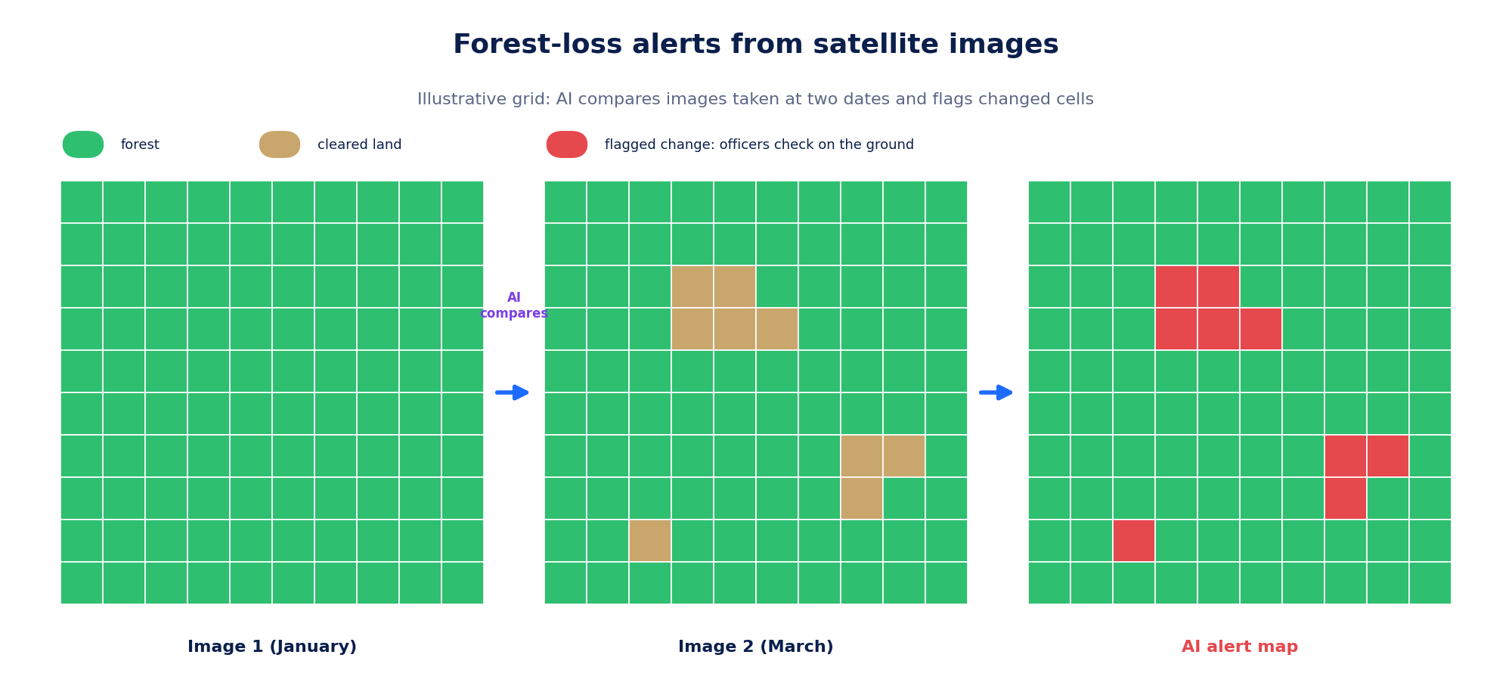
Figure 2.8: Spotting changes between two satellite images (illustrative grid).

Real-world applications
✔ VERIFIED REAL-WORLD APPLICATION • Global Forest Watch alerts
Global Forest Watch, an online platform, uses satellite data and algorithms to provide near-real-time alerts of tree-cover loss that governments, organisations and communities can use.

✔ VERIFIED REAL-WORLD APPLICATION • Google flood forecasting
Google has reported using AI with river and weather data to produce flood forecasts and warnings, starting in India and later expanding to many other countries through its Flood Hub service.

✔ VERIFIED REAL-WORLD APPLICATION • Rainforest Connection
The non-profit Rainforest Connection places recycled phones in forests; AI listens for sounds such as chainsaws and sends alerts to rangers.

◆ HYPOTHETICAL EXAMPLE (created for learning) • School air-quality alert
Imagine a city that places low-cost sensors near schools. An AI model predicts pollution spikes 48 hours ahead, and schools receive a message advising indoor activities on those days. (Invented example.)

✔ Benefits  - Early warnings can save lives and property  - Monitors huge areas cheaply and continuously  - Faster response to illegal logging  - Helps use renewable energy efficiently | ⚠ Limitations & challenges  - Clouds can block satellite views  - False alarms need human checking  - AI consumes energy, creating its own footprint  - Data gaps in poorer or remote regions  - Local communities must be involved in decisions

THINK & DISCUSS
AI can help the environment but also uses energy. How could you decide whether a particular AI project is a net benefit?

 | INDUSTRY 9 OF 9  Marine Science  Understanding the ocean with data.

Why AI here?
The ocean covers about 71% of Earth’s surface, yet much of it is still poorly observed. Scientists gather satellite images, ship-tracking signals, underwater cameras, hydrophones (underwater microphones), buoys and underwater drones. The data is too large to study by hand, so AI helps to identify species, track animals, map coral reefs, watch fishing activity and forecast conditions such as harmful algal blooms.
Many ships broadcast their position using the Automatic Identification System (AIS). AI can study these tracks to find movement patterns typical of fishing. Ships that switch off AIS or do not carry it remain hard to see, so AI results are a clue, not proof.

The AI pipeline in marine science
Stage | What happens
Data | Satellite images, AIS ship tracks, underwater photos and video, whale and fish sounds, sea-temperature readings.
Patterns | Models learn what fishing movements, coral, fish shapes and whale calls look and sound like.
Prediction | Predicts “this vessel is probably fishing”, “this is the same whale as last year” or “this reef area is damaged”.
Decision & action | Authorities, scientists and fishing communities use the maps to plan patrols, protect species and manage fish stocks.
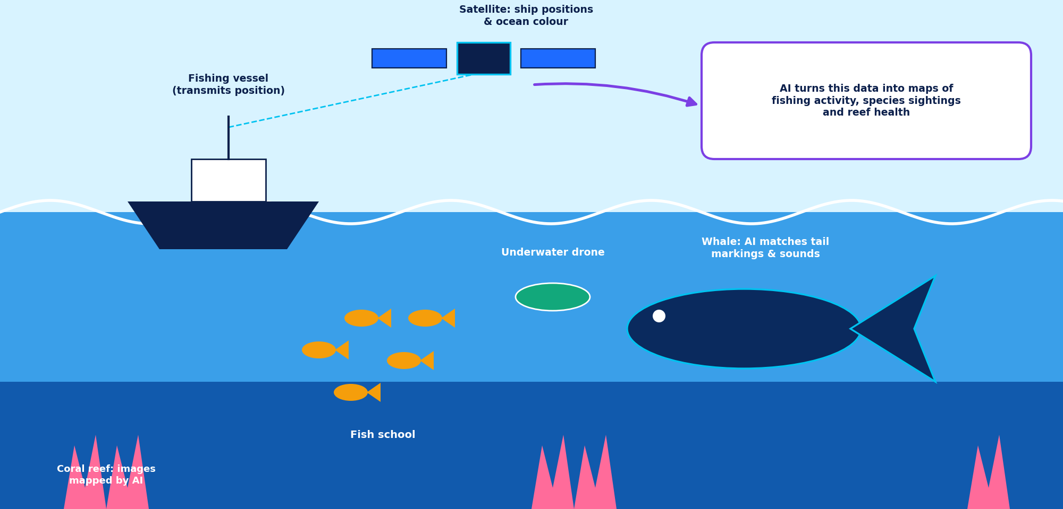
Figure 2.9: Data sources and AI uses in marine science (illustrative scene).

Real-world applications
✔ VERIFIED REAL-WORLD APPLICATION • Global Fishing Watch
Global Fishing Watch, an international non-profit, uses machine learning on vessel-tracking data and satellite imagery to show apparent fishing activity around the world in a public map.

✔ VERIFIED REAL-WORLD APPLICATION • Happywhale and whale identification
The Happywhale platform lets people upload photos of humpback whale tails, whose markings are unique, and uses image-matching AI to identify individual whales; a 2018 data-science competition on Kaggle helped improve such methods.

✔ VERIFIED REAL-WORLD APPLICATION • Allen Coral Atlas
The Allen Coral Atlas uses satellite images and machine learning to map shallow coral reefs and their condition around the world.

◆ HYPOTHETICAL EXAMPLE (created for learning) • Sardine shoal alert
Imagine a fishing co-operative that receives a phone message each evening showing where sardine shoals are likely tomorrow, predicted from sea temperature and ocean-colour data. Fishers report catches, which improves the next day’s forecast. (Invented example.)

✔ Benefits  - Watches remote areas continuously  - Processes huge image and sound archives quickly  - Helps protect species and reefs  - Supports fair, sustainable fishing | ⚠ Limitations & challenges  - Little labelled data from the deep sea  - Underwater hardware is costly and can fail  - Vessels without AIS stay invisible  - Rare species are poorly represented in training data  - Marine experts must verify AI findings

THINK & DISCUSS
Why can AIS data alone not prove that a ship is fishing illegally? What other evidence would an officer need?

PART 3
Benefits, Limits & Responsible AI
Using AI wisely

3.1 Weighing benefits and limitations
Across all nine industries the same pattern appears: AI brings speed, scale and early warning, but also needs good data, careful testing and human responsibility. The best innovators ask both questions: What can this do? What could go wrong?
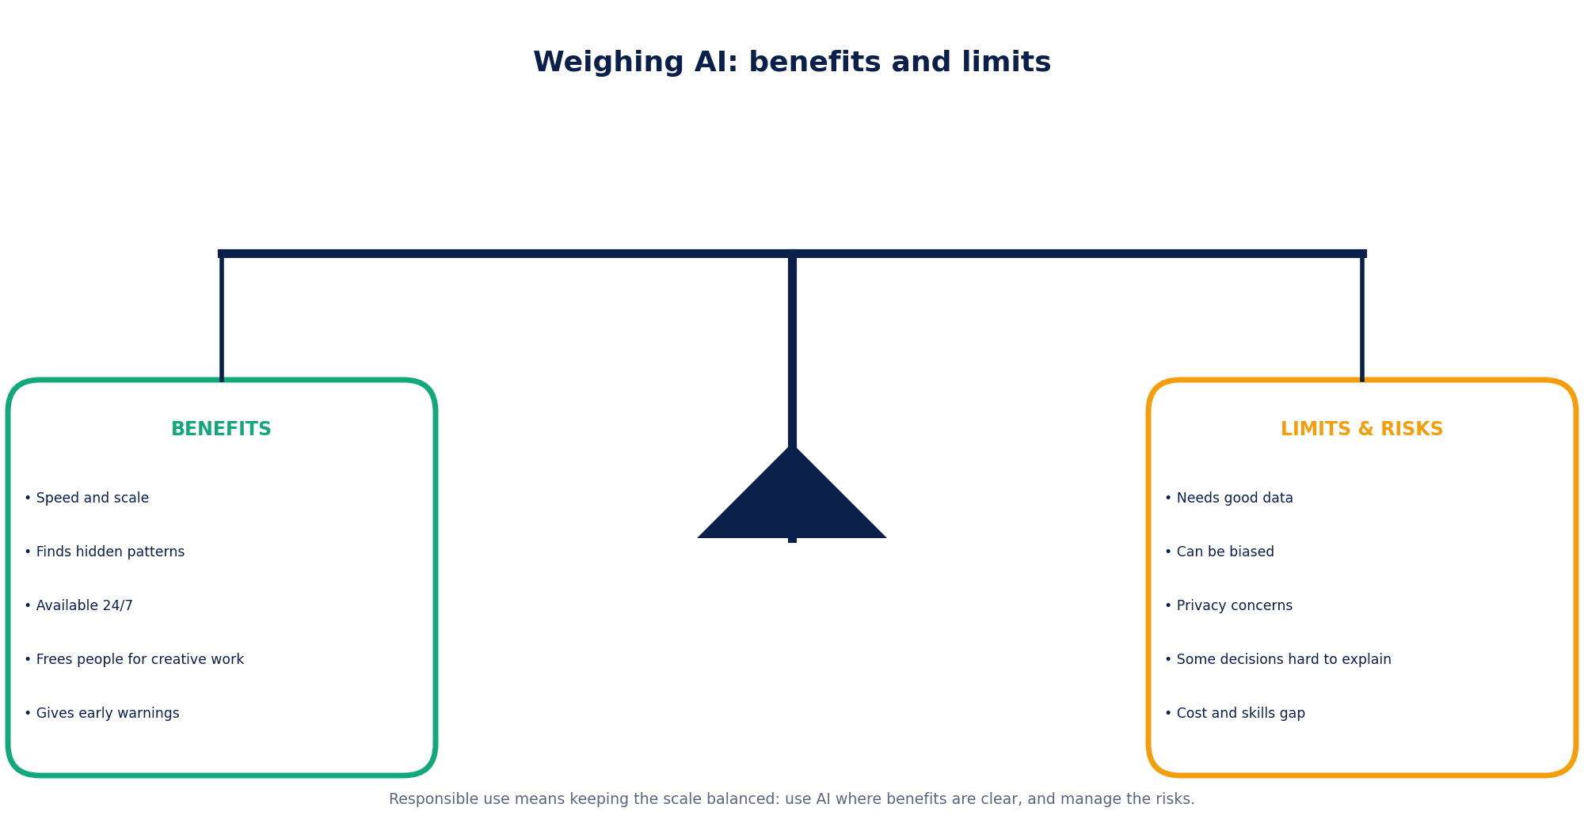
Figure 3.1: Benefits and limits must be weighed together.
Industry | Biggest benefit | Biggest risk | Key safeguard
Healthcare | Earlier detection | Missed or wrong diagnosis | Clinician review; regulation
Education | Personalised practice | Wrong answers; over-reliance | Teacher guidance; fact-checking
Agriculture | Saves inputs, protects yield | Model not suited to local conditions | Local testing; extension workers
Transportation | Fewer accidents, shorter trips | Rare unexpected situations | Safety limits; staged rollout
Banking | Fast fraud detection | False alarms; unfair credit scores | Appeal rights; fairness audits
Manufacturing | Less downtime and waste | False alarms; cyber-attacks | Operator checks; secure networks
Business | Better planning | Privacy; filter bubbles | Consent; transparent policies
Environment | Early warnings | False alarms; energy use | Ground checks; community input
Marine science | Monitoring remote seas | Blind spots (no AIS, rare species) | Expert verification

3.2 Key challenges of AI in industry
Challenge | What it means | Example | Typical fix
Data quality & quantity | Poor, small or outdated data leads to poor models | Blurry retina photos give unreliable results | Clean data; set image quality standards
Bias | The model performs unevenly for different groups | Voice tool misses an accent (hypothetical) | Diverse data; test each group
Privacy & security | Personal data must be protected from misuse and attacks | Leak of health or bank records | Collect less; encrypt; control access
Explainability | Some models are “black boxes” | Customer cannot learn why a loan was refused | Explain key factors; human review
Reliability | AI can be confidently wrong (“hallucination”) | Chatbot invents a fact | Cite sources; verify; human check
Cost & access | Skills, sensors and internet are unevenly available | Small farms without connectivity | Low-cost tools; training; shared services
Jobs & skills | Tasks change; people need new skills | Inspectors work alongside vision systems | Reskilling; job redesign
Energy footprint | Training and running models uses electricity | Large cloud computing demand | Efficient models; clean energy

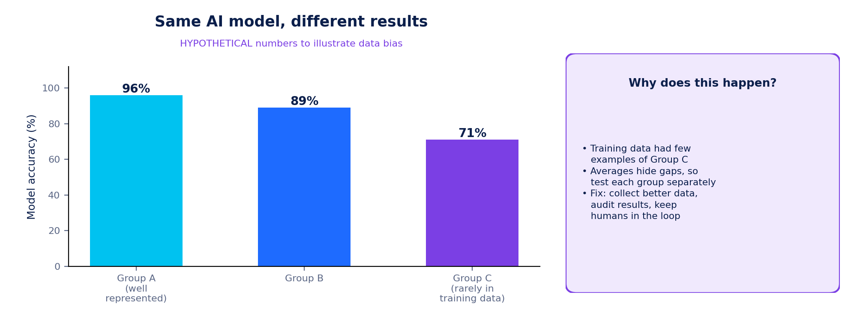
Figure 3.2: The same model can work very differently for different groups (hypothetical numbers).

3.3 Responsible use of AI
Many organisations and governments describe similar principles for responsible AI. Rules are developing quickly: for example, India’s Digital Personal Data Protection Act, 2023 sets rules for handling personal data, and the European Union’s AI Act (2024) regulates AI systems according to their level of risk. Whatever the law, good practice follows the six principles below.
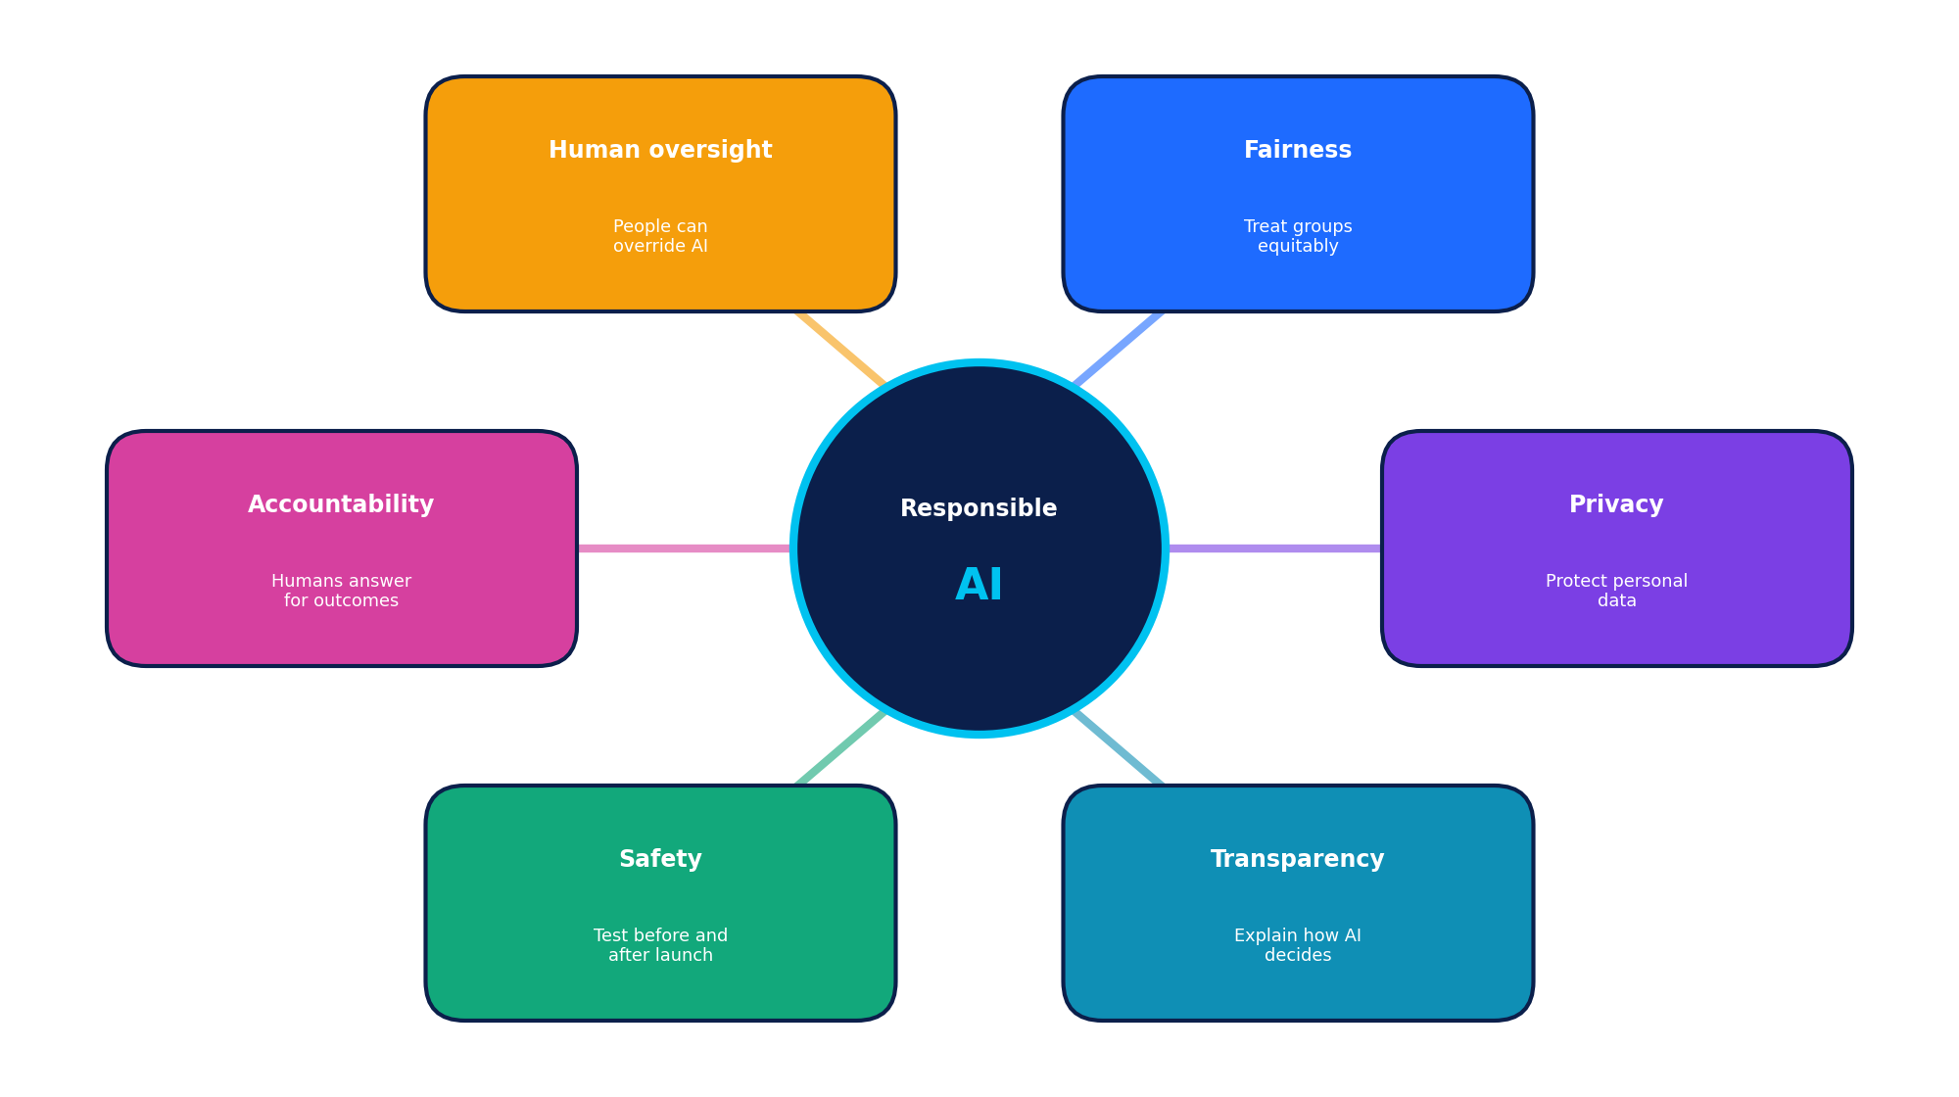
Figure 3.3: Six principles of responsible AI.
A FIVE-QUESTION CHECKLIST BEFORE USING AI
1. Data: Is the data appropriate, lawful and good enough for this purpose?
2. Harm: Who could be hurt if the AI is wrong, and how badly?
3. Fairness: Have we tested it on all the groups it will affect?
4. Explanation & appeal: Can we explain decisions, and can people challenge them?
5. Oversight: Is a responsible human in charge, and how will we monitor and fix problems?

WORKSHEET 1 OF 3
Worksheet 1
Foundations, Healthcare, Education & Agriculture
Name: ____________________________ Class: ________ Date: ______________
Answer all 12 questions. Total marks: 25. Use full sentences unless the question says otherwise.
1. Write the six steps of the AI innovation pipeline in the correct order. [1]

2. Distinguish between traditional rule-based software and machine learning. Give one example of each. [2]

3. Match each situation to the task type: classification, forecasting, recommendation, computer vision. [2]
(a) A spam filter sorts emails
(b) Predicting how many passengers will board a train tomorrow
(c) Suggesting the next video a viewer may like
(d) Reading a retina photo to look for signs of disease

Answers: (a) ____________ (b) ____________ (c) ____________ (d) ____________
4. Define “human-in-the-loop” and give one situation where it is essential. [2]

5. Why is AlphaFold described as an example of AI helping scientific discovery? [2]

6. Name two kinds of data used in healthcare AI and state what each can reveal. [2]

7. Why are results from an AI eye-screening tool reviewed by a doctor? [2]

8. Describe how an adaptive-learning app decides which question to show next. [2]

9. State two risks of relying heavily on AI chatbots for homework and one habit that reduces them. [2]

10. Name three data sources used in precision agriculture and one decision each can support. [3]

11. Why might a crop-disease app trained on cassava leaves fail when used on rice leaves? [2]

12. Label each item VERIFIED or HYPOTHETICAL and give a reason: (a) FDA authorisation of IDx-DR in 2018; (b) the ward early-warning dashboard in Chapter 1; (c) the Nuru cassava-disease app. [3]

WORKSHEET 2 OF 3
Worksheet 2
Transportation, Banking, Manufacturing & Business
Name: ____________________________ Class: ________ Date: ______________
Answer all 12 questions. Total marks: 25. Use full sentences unless the question says otherwise.
1. In a self-driving system, what does the “Predict” stage do, and why must it come before “Plan”? [2]

2. Compare a camera and radar as sensors in a vehicle: state one strength of each. [2]

3. Why does a maps app use machine learning rather than a fixed formula to estimate arrival time? [2]

4. A bank’s fraud model blocks a genuine payment. Name this type of error and suggest one way the bank can reduce its impact on the customer. [2]

5. List four pieces of information (features) a card-fraud model might use. [2]

6. Explain “bias in credit scoring” using a HYPOTHETICAL example of your own. State clearly that it is hypothetical. [2]

7. Look at Figure 2.6 (predictive maintenance). What does the AI notice on Day 44, and why is that valuable? [2]

8. Give two advantages and one limitation of AI visual inspection in a factory. [3]

9. What is a “digital twin”? [1]

10. Explain how a recommendation system might suggest a film using “people with similar viewing history”. [2]

11. A shop’s forecast says “120 units, between 105 and 135”. Explain why the range is useful to the manager. [2]

12. HYPOTHETICAL data: a bakery sold 80, 90, 85 and 95 loaves on Monday to Thursday. (a) Find the mean daily sales. (b) The AI adds 10% for a holiday on Friday. Calculate the forecast (nearest whole loaf). (c) Why should the bakery not rely on this single number? [3]

WORKSHEET 3 OF 3
Worksheet 3
Environment, Marine Science, Challenges & Responsible AI
Name: ____________________________ Class: ________ Date: ______________
Answer all 12 questions. Total marks: 31. Use full sentences unless the question says otherwise.
1. Explain how AI helps to detect deforestation from satellite images. [2]

2. Give two benefits and two limitations of using AI for flood forecasting. [4]

3. Why does the energy footprint of AI matter for environmental projects? [2]

4. What does AIS stand for, and why can AIS alone not detect all illegal fishing? [2]

5. Describe how photographs of whale tails help scientists, and what AI contributes. [2]

6. Using Figure 3.2, explain “data bias”. What would you do about Group C? [3]

7. Differentiate between privacy and security in AI systems. [2]

8. What is “explainability”, and why does it matter for loan or medical decisions? [2]

9. List three principles of responsible AI and give one practical action for each. [3]

10. HYPOTHETICAL: an AI hiring tool rejects most applicants from one college because past hires came from other colleges. Identify the problem and suggest two fixes. [3]

11. What is “hallucination” in generative AI, and how can a user protect themselves? [2]

12. DESIGN: choose an industry not covered in detail in this unit (for example, tourism, sports or retail). Describe one data source, one AI task, one benefit and one risk. Label it as hypothetical. [4]

MULTIPLE-CHOICE QUESTIONS
30 MCQs
Choose the single best answer for each question
Name: ____________________________ Class: ________ Date: ______________
Circle the letter of the best answer. Each question carries 1 mark. Transfer your answers to the answer grid on the last MCQ page.
1. AI is said to “power innovation” mainly because it:
(A) replaces every human worker | (B) only stores large files
(C) turns data into predictions and decisions that create new or better products and services | (D) makes computer hardware cheaper
2. What is the first step in the AI innovation pipeline?
(A) Data | (B) Prediction
(C) Feedback | (D) Action
3. Machine learning differs from traditional rule-based software because it:
(A) never needs any data | (B) can only use fixed IF-THEN rules
(C) cannot make predictions | (D) learns its behaviour from examples and can improve with new data
4. Predicting next week’s rainfall in millimetres is mainly which task type?
(A) Classification | (B) Forecasting (regression)
(C) Clustering | (D) Speech recognition
5. Spotting an unusual card payment that does not fit a customer’s habits is an example of:
(A) image generation | (B) anomaly detection
(C) speech synthesis | (D) route planning
6. “Human-in-the-loop” means that:
(A) humans train an AI only once | (B) AI works without any data
(C) humans are fully replaced | (D) people review or can override the AI’s outputs
7. AI screening of retina photographs mainly helps by:
(A) highlighting likely disease so patients can be referred sooner | (B) replacing eye hospitals
(C) manufacturing spectacles | (D) storing medicine bills
8. AlphaFold is best known for:
(A) driving cars | (B) detecting card fraud
(C) predicting 3-D protein structures | (D) forecasting rainfall
9. Adaptive learning platforms personalise practice using:
(A) only the student’s age | (B) random selection only
(C) the teacher’s mood | (D) data such as right/wrong answers and time taken
10. A key risk of AI tutors is that they:
(A) may give confident but incorrect answers | (B) cannot process text
(C) always refuse to answer | (D) can only work offline
11. “Precision agriculture” means:
(A) using the same amount of water everywhere | (B) avoiding all technology
(C) applying water and inputs only where and when they are needed | (D) growing a single crop for ever
12. Which data is LEAST likely to be used in a crop-sowing advisory?
(A) Rainfall records | (B) Customer reviews of a streaming service
(C) Soil-moisture readings | (D) Weather forecasts
13. Which sequence best describes how a self-driving system works after sensing?
(A) Perceive → Predict → Plan → Control | (B) Plan → Perceive → Control → Predict
(C) Control → Plan → Predict → Perceive | (D) Predict → Control → Perceive → Plan
14. Lidar sensors work by using:
(A) sound waves under water | (B) ordinary radio broadcasts
(C) laser pulses to build a 3-D map | (D) Wi-Fi signals only
15. A bank blocks a genuine payment by mistake. This error is a:
(A) true positive | (B) false positive
(C) true negative | (D) false negative
16. Which feature would be LEAST relevant to a card-fraud model?
(A) Transaction amount | (B) Location of the payment
(C) Time of day | (D) The customer’s favourite colour
17. Predictive maintenance aims to:
(A) repair machines only after they break | (B) replace every machine each year
(C) increase machine vibration | (D) predict faults early so repairs are scheduled before breakdown
18. A “digital twin” is:
(A) two identical robots | (B) a virtual copy of a machine or plant used for simulation
(C) a backup hard disk | (D) a duplicate employee record
19. Streaming-service recommendations mainly rely on:
(A) viewing history and patterns shared with similar users | (B) the weather outside only
(C) random choice | (D) prime numbers
20. A forecast of “120 ± 15 units” tells a manager that:
(A) exactly 120 units will sell | (B) the model has failed
(C) demand will probably be between about 105 and 135 units | (D) no units will be sold
21. Global Forest Watch is an example of using satellite data and algorithms for:
(A) predicting share prices | (B) detecting tree-cover loss
(C) translating languages | (D) reading medical scans
22. Why can cloud cover limit environmental AI that uses optical satellites?
(A) Clouds delete stored data | (B) Clouds heat the sensors
(C) Clouds block the satellite’s view of the ground | (D) Clouds speed up models
23. In marine science, AIS stands for:
(A) Artificial Intelligence System | (B) Advanced Imaging Sonar
(C) Aquatic Information Service | (D) Automatic Identification System
24. “Dark vessels” are ships that:
(A) do not broadcast their position, making them hard to track with AIS | (B) are painted black
(C) travel only underwater | (D) have no engines
25. Individual humpback whales can be identified from photographs of their:
(A) tail flukes | (B) teeth
(C) shadows | (D) bubble trails
26. Data bias occurs when:
(A) the computer is old | (B) the output is very long
(C) users type short prompts | (D) training data under-represents some groups, so the model works worse for them
27. Which action best protects privacy?
(A) Keeping all data for ever | (B) Sharing health records openly
(C) Collecting only the data needed and securing it | (D) Ignoring consent
28. An AI model whose decisions are hard to explain is often called a:
(A) open book | (B) black box
(C) glass wall | (D) clear lens
29. Which statement about responsible AI is TRUE?
(A) Accountability can be left to the AI itself | (B) Testing is unnecessary after launch
(C) Only programmers need to care | (D) Fairness, transparency and human oversight are core principles
30. Which example in this workbook is HYPOTHETICAL rather than verified?
(A) A bakery chain forecasting loaves using weather and holiday data | (B) The FDA authorisation of IDx-DR
(C) Global Fishing Watch | (D) The AlphaFold Protein Structure Database

MCQ answer grid
1 | 2 | 3 | 4 | 5 | 6 | 7 | 8 | 9 | 10 | 11 | 12 | 13 | 14 | 15
16 | 17 | 18 | 19 | 20 | 21 | 22 | 23 | 24 | 25 | 26 | 27 | 28 | 29 | 30

CLASSROOM ACTIVITIES
Five Activities
Learn by doing: discuss, calculate, design and pitch

A1 | Pipeline Relay  ⏱ 25 minutes • ☺ Groups of 4 • Materials: Scenario cards, six pipeline cards per group (Data, Patterns, Prediction, Decision, Action, Feedback), marker pens
Aim: Apply the six-step AI pipeline to different real-life scenarios.
1. The teacher gives each group a scenario card: (A) a weather app, (B) fraud detection on card payments, (C) a crop-advice SMS service, (D) a bus-crowding forecaster (hypothetical).
2. Groups write, on six sticky notes, what happens at each pipeline step for their scenario.
3. Relay: one member at a time runs to the board and places one note in the correct order. The next member may correct a misplaced note before adding theirs.
4. Compare boards. Discuss: which step was hardest to describe? Where could a human step in?

Scenario | Data used | Prediction made | Decision / action

Reflection: Which pipeline step was the hardest to describe, and why?

A2 | Data Detectives  ⏱ 30 minutes • ☺ Pairs • Materials: Industry cards, worksheet below
Aim: Identify data sources and AI tasks for an industry and judge which are realistic.
1. Each pair receives one industry card (healthcare, education, agriculture, transportation, banking, manufacturing, business, environment or marine science).
2. List four data sources that the industry can collect (sensors, images, text, records, sound).
3. For each data source, name one AI task from Section 1.3 and one decision it could support.
4. Swap tables with another pair. The reviewing pair marks each row “realistic”, “needs more data” or “raises privacy concerns”.

Data source | AI task | Decision it supports | Review

A3 | Human or AI? The Decision Debate  ⏱ 35 minutes • ☺ Teams of 5 and the class • Materials: Case cards, stakes–reversibility grid below
Aim: Decide how much human control different AI decisions need.
1. The teacher reads five decisions: (1) autocorrect on a phone; (2) a bank refuses a loan; (3) an AI flags a possible tumour on a scan; (4) a bus app suggests a route; (5) a factory AI shuts down a machine because of overheating.
2. Teams place each decision on the grid below by rating the stakes (low/high) and reversibility (easy/hard to undo).
3. Teams decide: AI alone, AI with human review, or human decides with AI as advice. Each team defends its choice for one decision in 60 seconds.
4. The class votes and discusses disagreements.

Decision | Stakes (L/H) | Easy to undo? (Y/N) | Who should decide?

Stakes–reversibility grid: write the decision numbers (1–5) in the correct box.
 | Easy to undo | Hard to undo
Low stakes
High stakes

A4 | Spot the Bias Gap  ⏱ 30 minutes • ☺ Pairs • Materials: Calculator, data table below (hypothetical data)
Aim: Use data to discover how overall accuracy can hide unfair differences between groups.
1. A voice-assistant model was tested on 50 spoken commands from each of three speaker groups (HYPOTHETICAL data): Group A understood correctly 48 times, Group B 40 times, Group C 31 times.
2. Calculate each group’s accuracy (correct ÷ 50 × 100) and the overall accuracy for all 150 commands.
3. Discuss: why does the overall figure look acceptable while Group C is poorly served?
4. Write two actions the developers should take, and one question they should ask before launching.

Group | Correct out of 50 | Accuracy (%) | Comment
Group A | 48
Group B | 40
Group C | 31
Overall

Reflection: Why is overall accuracy not enough to judge a system?

A5 | AI Innovation Pitch (Design Sprint)  ⏱ 45 minutes • ☺ Teams of 4 • Materials: Pipeline canvas below, chart paper, peer-scoring slips
Aim: Design a responsible AI solution for a school or community problem and pitch it in two minutes.
1. Choose a real problem in your school or neighbourhood (for example, food waste in the canteen, long bus queues, water use in the garden).
2. Fill in the canvas below: problem, data you could collect, AI task, prediction, decision/action, human role, benefit, risk and safeguard.
3. Prepare a two-minute pitch. Everyone must speak.
4. Peers score each pitch out of 20 using the rubric: clear problem (4), sensible data and AI task (4), pipeline logic (4), responsible-AI thinking (4), communication (4).

Canvas item | Our answer
Problem
Data we could collect
AI task
Prediction
Decision / action
Human role
Benefit
Risk & safeguard

BRAIN GAMES
Four Puzzles
Word search, secret code, logic grid and odd-one-out

Puzzle 1: AI Word Search
Find the ten hidden words. They may run right, down, diagonally, left or up. Tick each word in the list when found.
 | WORD LIST  ☐ SENSOR  ☐ PATTERN  ☐ FORECAST  ☐ DRONE  ☐ SATELLITE  ☐ PRIVACY  ☐ FEEDBACK  ☐ BIAS  ☐ LIDAR  ☐ CLUSTER
  N | D | X | B | C | O | O | I | X | T | C | L
  M | D | Y | C | A | V | I | R | P | S | P | M
  E | U | B | P | E | N | O | R | D | A | E | G
  K | S | P | A | T | T | E | R | N | C | A | J
  C | A | D | O | R | T | L | Z | E | E | N | R
  A | T | Z | A | O | O | R | X | C | R | P | B
  B | E | U | L | S | B | W | U | U | O | E | I
  D | L | C | K | N | H | U | E | U | F | F | A
  E | L | I | S | E | H | R | A | D | I | L | S
  E | I | P | J | S | K | R | W | A | Y | O | Q
  F | T | E | K | E | E | B | J | R | T | Y | V
  H | E | B | N | E | R | E | T | S | U | L | C

Puzzle 2: Secret Code Breakers
Five key terms from this unit have been hidden with a shift-3 cipher: every letter has moved three places forward in the alphabet (A→D, B→E, …, X→A, Y→B, Z→C). To decode, move each letter three places back (D→A, E→B, …).
A | B | C | D | E | F | G | H | I | J | K | L | M | N | O | P | Q | R | S | T | U | V | W | X | Y | Z
D | E | F | G | H | I | J | K | L | M | N | O | P | Q | R | S | T | U | V | W | X | Y | Z | A | B | C
Top row: decoded letter. Bottom row: coded letter.
# | Coded message | Decoded term
1 | SUHFLVLRQ DJULFXOWXUH
2 | GLJLWDO WZLQ
3 | UHVSRQVLEOH DL
4 | IHHGEDFN ORRS
5 | DQRPDOB GHWHFWLRQ

Puzzle 3: The Three Start-ups (Logic Grid)
Three start-ups (Nova, Orbit and Pixel) each work in a different industry, use a different data source and perform a different AI task. Use the clues to complete the table. (All start-ups are HYPOTHETICAL.)
Option group | Industries | Data sources | AI tasks
Choose from: | Agriculture, Manufacturing, Marine | Soil-moisture readings, Machine vibration, Underwater audio | Anomaly detection, Species classification, Yield forecasting

1. The company that uses underwater audio classifies species.
2. The company that uses machine vibration performs anomaly detection.
3. The Agriculture company uses neither machine vibration nor underwater audio.
4. The Manufacturing company does not classify species.
5. Nova does not work in Marine Science.
6. Orbit does not do yield forecasting and does not use machine vibration.
7. Pixel is not the Agriculture company.

Start-up | Industry | Data source | AI task
Nova
Orbit
Pixel

Puzzle 4: Odd One Out and Pipeline Scramble
Part A. In each row circle the odd one out and write why.
# | Choices | Why is it the odd one out?
1 | Camera • Lidar • Radar • Steering wheel
2 | Netflix • Amazon • Spotify • Global Forest Watch
3 | Fraud detection • Credit scoring • Banking chatbot • Soil-moisture sensor
4 | Fairness • Privacy • Accountability • Unlimited data collection
5 | Sowing-date advice • Pest detection • Irrigation scheduling • Card-fraud scoring
Part B. Unscramble the six pipeline steps, then number them 1–6 in the correct pipeline order.
Scrambled | Unscrambled | Pipeline step number
ATDA
NETTRAPS
CRIPTONIDE
SODICINE
TOCAIN
BACKFEED

QUICK QUIZ
5-Minute Quick Quiz
10 questions, 1 mark each. Short answers only.
Name: ____________________________ Class: ________ Date: ______________
# | Question | Your answer
1 | True or False: A teacher should check AI-generated marks or feedback before they are final.
2 | Name the sixth and last step of the AI innovation pipeline.
3 | Which vehicle sensor is best at reading road signs and lane colours?
4 | True or False: A customer should never be able to question or appeal an AI loan decision.
5 | The Allen Coral Atlas uses satellite images and AI to map which marine habitat?
6 | True or False: Drone images alone are enough for a sowing-date advisory; weather data is not needed.
7 | Give one benefit of predictive maintenance besides avoiding a breakdown.
8 | True or False: AI used for the environment never consumes energy itself.
9 | True or False: Hallucination means an AI can state false information in a confident way.
10 | Which task type groups similar customers without pre-set labels?

Score: ______ / 10

CHAPTER ASSESSMENT
Unit 3 Assessment
AI Applications: AI Powers Innovation; AI Across Industries
Name: ____________________________ Class: ________ Date: ______________
Time: 45 minutes | Total marks: 30 | Sections: A, B, C, D | Calculator allowed
Read every question carefully. Write answers in the spaces provided. Questions labelled HYPOTHETICAL use invented data.

Section A: Multiple-choice questions (8 × 1 = 8 marks)
1. Which output is an example of a PREDICTION rather than a DECISION? [1]
(A) “Block this payment” (B) “82% chance this transaction is fraud”
(C) “Call the customer” (D) “Send an OTP”
2. Which application mainly uses satellite images to detect change over time? [1]
(A) Forest-loss alerts (B) A banking chatbot
(C) A recommendation engine (D) An adaptive quiz app
3. A voice assistant understands one accent much worse than others. The most likely first cause is: [1]
(A) The speakers talk too loudly (B) The training data had very few examples of that accent
(C) The phone battery is low (D) Too many people use the app
4. Which is the best example of human oversight? [1]
(A) A doctor reviews an AI-flagged scan before making a diagnosis (B) An AI sends prescriptions automatically
(C) A patient reads a result alone (D) Scans are never seen by a doctor
5. A crop-advice model trained in one region may fail in another because: [1]
(A) It never needs data (B) Soils, climates and crops may differ from its training data
(C) Farmers do not use phones (D) It uses too little electricity
6. The term “predictive maintenance” is most closely linked to which industry? [1]
(A) Education (B) Banking
(C) Manufacturing (D) Retail advertising
7. Which is an example of anomaly detection in marine science? [1]
(A) Naming a fish species from a photo (B) Flagging a ship whose movement is unusual for its type
(C) Recording sea temperature (D) Playing whale sounds
8. Calling an example “hypothetical” means that it: [1]
(A) was verified in the real world (B) is false information
(C) is an invented but realistic scenario to explain an idea (D) is illegal to use

Section B: Short answers (5 × 2 = 10 marks)
9. Define “pattern recognition” in AI and give one example from any industry. [2]

10. Explain why “feedback” is an important step in the AI pipeline. Give an example. [2]

11. Name two data sources used in a smart factory and one prediction AI can make from each. [2]

12. What is a “false negative” in a disease-screening model? Why can it be dangerous? [2]

13. State two ways AI can help protect the oceans, and name the data used for each. [2]

Section C: Application (2 × 4 = 8 marks)
14. HYPOTHETICAL data: a fraud model examined 1,000 card payments, of which 20 were truly fraudulent. The model flagged 30 payments, and 15 of those were truly fraudulent. (a) What percentage of the real fraud did it catch? (b) How many genuine payments were wrongly flagged? (c) What percentage of the flagged payments were truly fraud? (d) Suggest one way the bank could handle the wrongly flagged payments. [4]

15. HYPOTHETICAL: a city plans to use AI with traffic-camera video to change signal timings at busy junctions. Identify (a) the data, (b) the AI task, (c) one benefit and one risk, and (d) one safeguard. [4]

Section D: Extended response (1 × 4 = 4 marks)
16. Choose any ONE industry from this unit. Explain how AI uses data, finds patterns and makes predictions in that industry to support decisions. Then evaluate one benefit and one challenge. [4]

Section | Questions | Marks available | Marks scored
A | 1–8 | 8
B | 9–13 | 10
C | 14–15 | 8
D | 16 | 4
TOTAL | 16 questions | 30

CASE STUDY 1 OF 2 • VERIFIED
Screening for Diabetic Retinopathy
How AI can help find an eye disease before sight is lost

Background. Diabetes can damage the blood vessels in the retina, the light-sensitive layer at the back of the eye. This condition, diabetic retinopathy, is a leading cause of preventable blindness. If found early, treatment can protect sight, but many regions have too few eye specialists to examine every person with diabetes.
✔ VERIFIED REAL-WORLD APPLICATION • What public sources report
• In 2016, Google researchers published a study in the journal JAMA showing that a deep-learning model could detect diabetic retinopathy in retina photographs with high accuracy compared with expert graders.
• Google Health later tested a version of the system with partners including eye hospitals in India (such as Aravind Eye Care System and Sankara Nethralaya) and in Thailand.
• In 2018 the US FDA authorised IDx-DR, the first autonomous AI diagnostic system, for use in primary care.
• A 2020 research study of clinics in Thailand reported practical problems, such as poor lighting that made images unusable and slow internet that delayed results.

What this teaches us. Even a model that works well in the lab must also work in real clinics, with real equipment, real internet connections and busy staff. Technology must be designed together with the people who use it.

Questions (15 marks)
1. Complete the pipeline for this case. [4]
Stage | In diabetic retinopathy screening
Data
Patterns
Prediction
Decision & action
2. Explain why AI screening could help regions that have few eye specialists. [2]

3. Name two practical problems found in real clinics and suggest one solution for each. [3]

4. Explain what a “false negative” would mean for a patient here and why it is serious. [3]

5. Should the AI alone decide whether a patient is referred to a specialist? Give a reasoned answer with two points. [3]

CASE STUDY 2 OF 2 • VERIFIED
AI Sowing Advice for Farmers
Using weather data and SMS to help small farmers decide when to sow

Background. In rain-fed farming, sowing too early or too late can lead to crop failure, because a dry spell may follow the first rains. Farmers traditionally relied on experience and the start of the monsoon, but weather patterns are changing.
✔ VERIFIED REAL-WORLD APPLICATION • What public sources report
• In 2016 the research institute ICRISAT and Microsoft piloted an AI-based sowing advisory with groundnut farmers in Andhra Pradesh, India.
• The system analysed historical weather records and current conditions to suggest suitable sowing windows.
• Advice was sent to farmers as text messages in the local language, so no smartphone or internet was needed.
• The project reported that farmers who followed the advice had better yields; later work added further advice for other farm decisions.

What this teaches us. Useful AI can be simple and accessible: an SMS can carry the result of complex analysis. But results depend on local data, and farmers need to trust and understand the advice.

Questions (15 marks)
1. List the data used in this project and match it to the four pipeline stages (data, patterns, prediction, decision & action). [4]

2. Why was it important to send advice by SMS in the local language? [2]

3. Describe two risks if the advice is wrong and one safeguard for each. [3]

4. How could the project check fairly whether the advice really improved yields? (Hint: compare groups.) [3]

5. HYPOTHETICAL: suggest how this idea could be adapted for another crop or region. What new data would be needed? [3]

PRACTICAL MINI-PROJECT
AI Industry Impact Brief
Research one industry, evaluate one application and design an improvement

Task. Work alone or in pairs. Choose one industry from Part 2 and produce a two-page AI Industry Impact Brief and a three-minute presentation. Time: about one week.

Step-by-step plan
Step | What to do | Output
1 Choose | Pick an industry and one verified AI application. Find at least two reliable sources (company, research, government or news). | Source list with links and dates
2 Map | Describe the application using the six-step pipeline. Name the AI task type from Section 1.3. | Completed pipeline canvas
3 Evaluate | List two benefits, two limitations and one ethical question. Identify who could be affected. | Evaluation table
4 Design | Propose one HYPOTHETICAL improvement or new use. Say what data it needs and what could go wrong. | Half-page design idea
5 Present | Create a one-page infographic and give a three-minute talk. Label verified vs hypothetical content. | Infographic + talk

Research table
Item | Your notes | Source (name, date, link)
Application name
Who built / uses it
Key facts
Results reported

Pipeline canvas
Stage | In my application
1 Data
2 Patterns
3 Prediction
4 Decision
5 Action
6 Feedback

Assessment rubric (20 marks)
Criterion | Marks | Full marks when…
Research & sources | 4 | Two or more reliable, dated sources; facts are accurate; verified and hypothetical content are clearly labelled
Pipeline accuracy | 4 | All six stages described correctly for this industry; task type correctly named
Evaluation | 4 | Two benefits, two limitations and an ethical question, supported by reasons
Original design idea | 4 | A realistic hypothetical idea with data needs, risks and safeguards
Presentation | 4 | Clear infographic, good timing, answers questions confidently

PART 6 • REVIEW
Chapter Summary
Twelve ideas to remember

Topic | Key point
Innovation | AI powers innovation by turning data into predictions that support better decisions, at a speed and scale people cannot match.
Pipeline | Data → patterns → prediction → decision → action → feedback. A prediction is an estimate; a decision is a choice.
Task types | Classification, forecasting, clustering, anomaly detection, recommendation, computer vision, language and optimisation appear in every industry.
Healthcare | AI reads scans and supports research (for example, protein structures), but doctors stay accountable.
Education | Adaptive learning personalises practice; AI tutors help but can be wrong, so students must check and think.
Agriculture | Weather, soil and image data guide sowing, irrigation and spraying; local testing and simple delivery (SMS) matter.
Transportation | AI predicts travel time and assists driving by perceiving, predicting, planning and controlling, within safety limits.
Banking | Risk scores flag fraud in milliseconds; false alarms, fairness and explanations are key concerns.
Manufacturing | Predictive maintenance and visual inspection reduce downtime and waste; digital twins allow safe testing.
Business | Forecasts and recommendations improve planning and service; uncertainty ranges and privacy must be respected.
Environment & marine | Satellites, sensors and sound data are analysed by AI for early warnings and monitoring; AIS and clouds create blind spots.
Responsible AI | Fairness, privacy, transparency, safety, accountability and human oversight guide good use. Label verified vs hypothetical.

KEY IDEA
Remember: AI = data + model + people. Strong results need all three.

PART 6 • REVIEW
Concept Map
How the ideas of Unit 3 connect

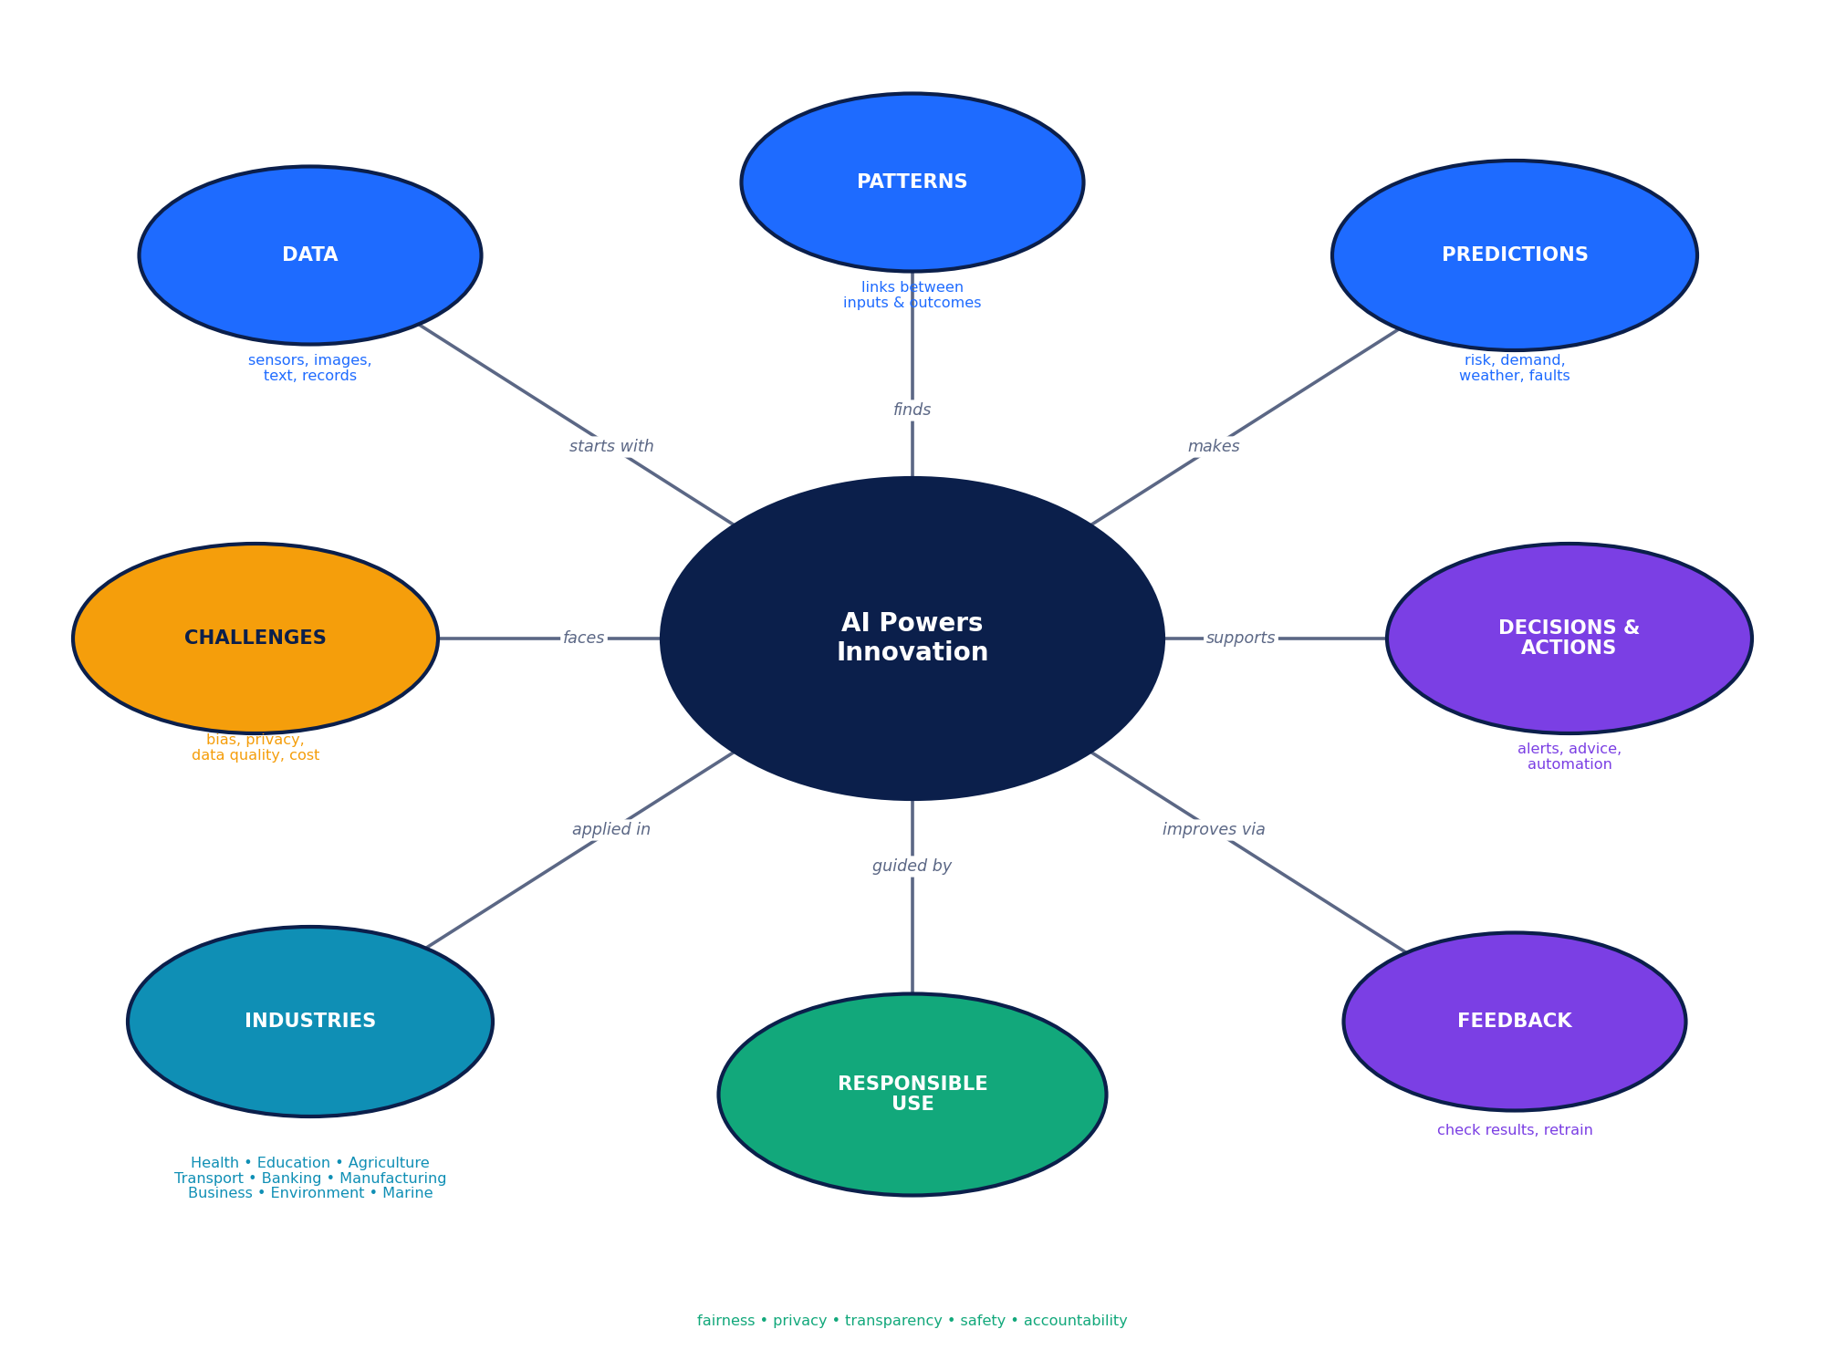
Figure 6.1: Concept map of AI Applications: AI Powers Innovation; AI Across Industries.
THINK & DISCUSS
Redraw this concept map from memory on a blank page, adding one real example (verified) to each outer bubble. Compare with a partner.

My own concept map (space for sketching)

PART 6 • REVIEW
Revision Exercises
Match, complete and correct

Exercise R1: Match the application to its field
1. AlphaFold | (a) Banking and finance
2. Nuru app | (b) Agriculture
3. Waymo | (c) Healthcare and biology research
4. Card-fraud scoring | (d) Marine science
5. Predictive maintenance | (e) Business and entertainment
6. Netflix | (f) Transportation
7. Global Forest Watch | (g) Environmental protection
8. Allen Coral Atlas | (h) Manufacturing
Write your matches (for example 1-c): ______________________________________________________

Exercise R2: Complete the paragraph
Word bank: bias • data • explainability • feedback • human-in-the-loop • patterns • prediction • privacy
AI systems start with (1) ______, which a model studies to find (2) ______. The model then makes a (3) ______, such as a risk score. A person or software turns this into a decision. Results are recorded as (4) ______ so that the model improves. A design where people can review or override AI is called (5) ______. If training data under-represents a group, the model may show (6) ______. Protecting personal information is a matter of (7) ______, and being able to describe why an AI gave a result is called (8) ______.

Exercise R3: Correct the false statements
1. “AI always gives an exact, certain answer.” [1]

2. “A prediction and a decision mean the same thing.” [1]

3. “Hypothetical examples in this workbook are real products tested in the field.” [1]

4. “If a model is 80% accurate overall, it must be fair for every group.” [1]

5. “Once an AI system is launched, it no longer needs monitoring.” [1]

PART 6 • REVIEW
Glossary
Forty key terms

AIS | Automatic Identification System: ship-tracking signals broadcast by vessels. | Hydrophone | An underwater microphone.
Adaptive learning | Teaching software that changes tasks to suit each learner. | Innovation | Turning a new idea into something useful.
Anomaly detection | Finding data that differs from the normal pattern. | Lidar | A sensor that uses laser pulses to map distance in 3-D.
Bias (data) | Unfair or uneven results caused by unrepresentative data or design. | Machine learning | AI that learns rules from examples in data.
Black box | A model whose reasons for a result are hard to explain. | Model | The learned system that turns inputs into predictions.
Classification | Assigning an item to a category. | NLP | Natural language processing: AI for text and speech.
Clustering | Grouping similar items without pre-set labels. | Pattern | A regularity in data that a model can learn.
Computer vision | AI that understands images and video. | Precision agriculture | Using inputs only where and when needed.
Credit scoring | Estimating how likely a borrower is to repay. | Prediction | An estimate of an unknown outcome.
Data | Facts as numbers, text, images or sound used to train and run AI. | Predictive maintenance | Fixing equipment before it fails, guided by data.
Deep learning | Machine learning with many-layered neural networks. | Privacy | Protecting and fairly using personal information.
Demand forecasting | Predicting how much of a product will be needed. | Radar | A sensor that uses radio waves to measure distance and speed.
Digital twin | A virtual copy of a machine or plant fed by real data. | Recommendation system | Software that suggests items a user may like.
Explainability | Being able to describe why an AI gave a result. | Responsible AI | Using AI fairly, safely, transparently and accountably.
False negative | A real case that the model misses. | Risk score | A number showing how likely an event (such as fraud) is.
False positive | A harmless case wrongly flagged. | Sensor | A device that measures the physical world.
Feedback loop | Using results to improve the next prediction. | Training data | The examples a model learns from.
Forecasting | Predicting a future number from past data. | Triage | Deciding who needs help first.
Hallucination | A fluent but false answer from generative AI. | Uncertainty range | The band within which a forecast will probably fall.
Human-in-the-loop | People review or can override AI decisions. | Verified example | A real application described in public sources.

PART 7 • TEACHER EDITION
Answer Keys & Marking Schemes
For teachers only: detach or hide before giving workbooks to students

This section contains verified answers, explanations and marking schemes for every question in the workbook. Open-response answers show model responses: award marks for any correct, relevant point expressed in the student’s own words.
Component | Marks | Where to find the key
Worksheet 1 | 25 | Section 7.1
Worksheet 2 | 25 | Section 7.1
Worksheet 3 | 31 | Section 7.1
30 MCQs | 30 | Section 7.2 (answers with explanations)
Quick quiz | 10 | Section 7.3
Activities 1–5 | Observation / 20 (A5) | Section 7.3
Puzzles 1–4 | Completion | Section 7.4
Case studies 1–2 | 15 + 15 | Section 7.5
Mini-project | 20 | Section 7.5
Chapter assessment | 30 (exactly) | Section 7.6 with section totals
Revision exercises | R1: 8, R2: 8, R3: 5 | Section 7.7

MARKING GUIDELINES
• Accuracy first: correct science and correct use of terms such as prediction vs decision, false positive vs false negative.
• Own words: do not require wording from the book if the idea is correct.
• Labelling: where a question asks for a hypothetical example, students must say it is hypothetical.
• Half marks: may be awarded where stated; round the question total to the nearest whole mark.
• Facts may change: real-world examples reflect public sources at the time of writing. If a company service or figure has changed, accept updated, sourced answers.

7.1 Worksheet answer keys

Worksheet 1: Foundations, Healthcare, Education & Agriculture (25 marks)
Q3 matches: (a) classification; (b) forecasting; (c) recommendation; (d) computer vision.
Q | Model answer | Marks & marking points
1 | Data → Patterns → Prediction → Decision → Action → Feedback. | [1] 1 mark for all six in correct order (0 if any two are swapped).
2 | Rule-based software follows fixed IF-THEN rules written by people (e.g., an alarm that sounds when temperature is above a set limit). Machine learning learns its rules from many examples in data and can improve with new data (e.g., a model that learns from past sensor data when a pump is likely to fail). | [2] 1 mark for the correct distinction; 1 mark for two suitable examples (one each).
3 | (a) classification; (b) forecasting (regression); (c) recommendation; (d) computer vision (reading images; it may also be called image classification). | [2] 0.5 mark each, rounded to the nearest whole mark. Accept “image classification” for (d).
4 | A system design in which a trained person reviews or can override the AI’s output before important actions are taken. Essential for medical diagnosis, loan rejection, or safety decisions. | [2] 1 mark definition; 1 mark appropriate high-stakes situation.
5 | It predicts the 3-D shape of proteins from their amino-acid sequence far faster than laboratory methods, and its predicted structures for over 200 million proteins were shared in a public database, helping researchers study diseases and design medicines. | [2] 1 mark for predicting protein shapes quickly; 1 mark for the benefit to research (database, medicines, disease study).
6 | Any two, e.g., retina photographs (signs of diabetic eye disease); chest X-rays (lung conditions); ECG traces (heart rhythm problems); lab results (infection or organ function). | [2] 1 mark per data type with correct insight.
7 | Because the AI gives only a probability, can make mistakes (false positives and false negatives), may perform worse on patients unlike its training data, and the doctor is accountable for the patient’s care and can consider other information. | [2] 1 mark for AI estimates can be wrong; 1 mark for accountability or extra clinical context.
8 | It records answers, time taken and hints used; a model estimates how well each topic is mastered and how hard each question is; it then selects a question that is challenging but achievable, and updates the estimate after the learner answers. | [2] 1 mark for data used; 1 mark for model estimating mastery/difficulty and choosing the next question.
9 | Risks (any two): wrong or invented answers; weaker thinking and writing skills; privacy of shared information; copying without understanding. Habit: check answers against a textbook or reliable source and write explanations in your own words. | [2] 0.5 mark per risk (max 1); 1 mark for a sensible habit.
10 | E.g., soil-moisture sensors (when to irrigate); satellite or drone images (where crops are stressed or weeds are growing); weather forecasts (when to sow or spray); phone photos of leaves (which disease is present). | [3] 1 mark per source linked to a decision (max 3).
11 | The model learned the visual patterns of cassava diseases only. Rice leaves and their diseases look different and were not in the training data, so predictions would be unreliable. New labelled rice images would be needed. | [2] 1 mark for training-data mismatch; 1 mark for need of new data or retraining.
12 | (a) Verified: reported by the FDA and developers. (b) Hypothetical: invented example created to explain the pipeline, not a named product. (c) Verified: developed by researchers at Penn State and partners, publicly documented. | [3] 1 mark per correct label with reason.

Worksheet 2: Transportation, Banking, Manufacturing & Business (25 marks)
Q | Model answer | Marks & marking points
1 | Predict estimates what other road users (cars, cyclists, pedestrians) will do next. Planning a safe path needs this information, otherwise the vehicle could choose a path that collides with where others will be. | [2] 1 mark for estimating others’ behaviour; 1 mark for linking to safe planning.
2 | Camera: recognises colours, lane markings, traffic signs and people. Radar: measures distance and relative speed of objects and keeps working better in fog, rain or darkness. | [2] 1 mark per correct strength.
3 | Travel time depends on many changing factors (traffic, weather, accidents, signals, time of day) that interact in complex ways. A model can learn these patterns from large amounts of past and live data, while a fixed formula cannot adapt. | [2] 1 mark for many changing factors; 1 mark for learning from data/adapting.
4 | False positive (a genuine event wrongly flagged). Reduce impact by sending an instant OTP/app confirmation, offering a quick call or easy unblock, or by sending uncertain cases to a human analyst. | [2] 1 mark for false positive; 1 mark for a reasonable remedy.
5 | Any four: amount, location, time of day, merchant type, device used, spending history, distance from last transaction, number of attempts. | [2] 0.5 mark each.
6 | Bias means the model treats groups unfairly because of unrepresentative or unfair data. Hypothetical example: a loan model trained mostly on data from salaried workers scores self-employed applicants as high-risk even when they repay on time. | [2] 1 mark for explanation; 1 mark for a plausible example labelled as hypothetical.
7 | It notices that vibration is drifting upwards from its normal level before it reaches the failure threshold. This gives time to schedule a repair, avoiding an unplanned breakdown, lost production and possible safety risk. | [2] 1 mark for noticing unusual drift; 1 mark for benefit of early repair.
8 | Advantages (any two): consistent, works at high speed, tireless, finds tiny defects, creates records. Limitation (any one): needs many labelled defect images, false alarms/missed defects, cost, struggles with new defect types. | [3] 1 mark per advantage (max 2); 1 mark for a limitation.
9 | A virtual copy of a machine or plant, kept up to date with real sensor data, used to simulate and test changes safely. | [1] 1 mark for virtual copy + use in simulation/testing.
10 | The system compares your viewing history with that of other users; it finds users with similar tastes and recommends films they enjoyed that you have not yet seen. | [2] 1 mark for finding similar users; 1 mark for recommending what they liked.
11 | It shows uncertainty. The manager can plan stock to cover the likely range (for example, order near the upper value for high-value items that must not run out, or the lower value for perishable items) instead of trusting one exact number. | [2] 1 mark for uncertainty; 1 mark for how it supports planning.
12 | (a) (80+90+85+95) ÷ 4 = 350 ÷ 4 = 87.5 loaves. (b) 87.5 × 1.10 = 96.25, so about 96 loaves. (c) It is a simple estimate; real demand varies (weather, events), so a range and a check by staff are needed. | [3] 1 mark for 87.5; 1 mark for 96 (accept 96.25); 1 mark for a sensible reason.

Worksheet 3: Environment, Marine Science, Challenges & Responsible AI (31 marks)
Q | Model answer | Marks & marking points
1 | The model compares images of the same area taken at different dates, learns to tell forest from cleared land, and flags cells where forest has changed so that officers can check them on the ground. | [2] 1 mark for comparing images over time; 1 mark for flagging for ground checks/alerts.
2 | Benefits: earlier warnings that save lives and property; covers many rivers cheaply and continuously. Limitations: depends on river and rainfall data that may be missing; false alarms or missed floods; warnings must reach and be trusted by communities. | [4] 1 mark each for any two benefits and any two limitations.
3 | Training and running models uses electricity and may add emissions; an environmental project should show that its benefits outweigh this footprint, for example by using efficient models and clean energy. | [2] 1 mark for energy use; 1 mark for benefit vs footprint.
4 | Automatic Identification System. Vessels can switch it off or may not carry it (“dark vessels”), and a track alone cannot prove what a ship was doing. | [2] 1 mark for the full form; 1 mark for the limitation.
5 | Tail markings are unique, so photos identify individual whales and track their movements over time. AI matches new photos with large collections far faster than people could. | [2] 1 mark for unique markings/identification; 1 mark for AI matching at scale.
6 | Data bias arises when training data under-represents some groups, so the model is less accurate for them (Group C: 71% vs 96% for Group A). Collect more representative data for Group C, test each group separately, and keep human review for affected decisions. | [3] 1 mark for definition; 1 mark for linking to figure; 1 mark for a sensible fix.
7 | Privacy is about collecting and using personal data fairly and only as needed, with consent. Security is about protecting data and systems from unauthorised access or attacks. | [2] 1 mark each for a correct description of each.
8 | Explainability is the ability to describe, in understandable terms, why an AI produced a result. It matters because affected people need reasons, to check for errors or unfairness and to challenge decisions. | [2] 1 mark for definition; 1 mark for importance.
9 | E.g., Fairness: test accuracy for each group. Privacy: collect only necessary data and encrypt it. Transparency: explain how results are produced. (Also accept safety, accountability, human oversight with suitable actions.) | [3] 1 mark per principle with a matching action (max 3).
10 | Problem: bias from unrepresentative historical data. Fixes (any two): use more balanced data; remove features that act as proxies; test results by group; require human review of rejections; allow candidates to appeal. | [3] 1 mark for naming bias/cause; 1 mark per fix (max 2).
11 | Hallucination is when an AI produces fluent but false or invented information. Users should cross-check important facts with reliable sources and ask for sources. | [2] 1 mark definition; 1 mark protective action.
12 | Open response. Example: Tourism (hypothetical): data source = booking and weather data; task = forecasting visitor numbers; benefit = better staffing and fewer crowds; risk = privacy of travellers’ data. | [4] 1 mark each for data, task, benefit, risk; deduct 1 if not labelled hypothetical (minimum 0).

7.2 MCQ answer key with explanations (30 marks)
Quick-check key: 1-C 2-A 3-D 4-B 5-B 6-D 7-A 8-C 9-D 10-A 11-C 12-B 13-A 14-C 15-B 16-D 17-D 18-B 19-A 20-C 21-B 22-C 23-D 24-A 25-A 26-D 27-C 28-B 29-D 30-A
Q | Answer | Why it is correct
1 | C | turns data into predictions and decisions that create new or better products and services. Innovation here means new or improved products and services; AI contributes by finding patterns, making predictions and supporting decisions.
2 | A | Data. All AI starts with data; patterns, prediction, decision, action and feedback follow.
3 | D | learns its behaviour from examples and can improve with new data. ML builds its rules from data; rule-based software follows rules written by people.
4 | B | Forecasting (regression). The output is a number, so it is forecasting or regression.
5 | B | anomaly detection. Anomaly detection finds items that differ from the normal pattern.
6 | D | people review or can override the AI’s outputs. Humans stay involved, especially when mistakes are costly.
7 | A | highlighting likely disease so patients can be referred sooner. It supports screening and referral; doctors still decide.
8 | C | predicting 3-D protein structures. AlphaFold predicts protein shapes from amino-acid sequences.
9 | D | data such as right/wrong answers and time taken. Learner data is used to estimate mastery and pick the next task.
10 | A | may give confident but incorrect answers. This is often called hallucination; answers should be checked.
11 | C | applying water and inputs only where and when they are needed. Data guides targeted use of inputs to save resources.
12 | B | Customer reviews of a streaming service. Streaming reviews are unrelated to sowing decisions.
13 | A | Perceive → Predict → Plan → Control. It must see, anticipate others, choose a path, then act.
14 | C | laser pulses to build a 3-D map. Lidar measures distance by timing reflected laser light.
15 | B | false positive. A genuine payment was wrongly flagged as fraud.
16 | D | The customer’s favourite colour. A favourite colour carries no information about fraud risk.
17 | D | predict faults early so repairs are scheduled before breakdown. Early warnings prevent unplanned downtime.
18 | B | a virtual copy of a machine or plant used for simulation. Teams test changes on the twin before changing the real system.
19 | A | viewing history and patterns shared with similar users. Recommenders find patterns across viewers and titles.
20 | C | demand will probably be between about 105 and 135 units. The ± value expresses uncertainty.
21 | B | detecting tree-cover loss. It provides near-real-time alerts of tree-cover loss.
22 | C | Clouds block the satellite’s view of the ground. Optical sensors cannot see through thick cloud.
23 | D | Automatic Identification System. AIS is a ship-tracking system.
24 | A | do not broadcast their position, making them hard to track with AIS. Without AIS signals they are invisible to AIS-based tracking.
25 | A | tail flukes. Fluke markings are unique, like fingerprints.
26 | D | training data under-represents some groups, so the model works worse for them. Poor representation in data leads to unequal performance.
27 | C | Collecting only the data needed and securing it. Data minimisation and security are core privacy practices.
28 | B | black box. A black box hides the reasons behind its outputs.
29 | D | Fairness, transparency and human oversight are core principles. People remain accountable and systems need ongoing monitoring.
30 | A | A bakery chain forecasting loaves using weather and holiday data. The bakery forecaster is an invented teaching example.

Answer distribution: A = 8, B = 7, C = 7, D = 8.

7.3 Quick quiz and activity notes

Quick quiz answers (10 marks)
Q | Answer
1 | True. AI can make errors and may be biased, so a teacher stays responsible.
2 | Feedback.
3 | Camera.
4 | False. Customers should receive an explanation and be able to appeal for human review.
5 | Coral reefs.
6 | False. Sowing advice depends strongly on rainfall and weather information.
7 | Any one: less downtime, lower repair cost, improved safety, longer machine life.
8 | False. Training and running models uses electricity.
9 | True.
10 | Clustering.

Activity teacher notes
Activity | What to look for / model responses
A1 Pipeline Relay | Check that Data comes first, Prediction is an estimate (not an action), and Feedback loops back to Data. Example answers: (A) data = weather readings; prediction = chance of rain; action = alert on phone. (B) data = transaction details; prediction = risk score; action = approve/OTP/block. (C) data = rainfall history, forecast; prediction = best sowing window; action = farmer sows. (D) data = ticket counts, weather; prediction = crowd level; action = extra buses.
A2 Data Detectives | Accept any realistic answers, e.g., Agriculture: soil-moisture readings → forecasting → irrigation timing; drone images → computer vision → where to spray; leaf photos → classification → disease treatment; weather forecast → forecasting → sowing date. Look for task names from Section 1.3 and for privacy awareness (e.g., health or bank data).
A3 Human or AI? The Decision Debate | Suggested: (1) low stakes, easy to undo → AI alone. (2) high stakes → AI with human review and explanation/appeal. (3) high stakes, serious if missed → AI advises, doctor decides. (4) low stakes → AI alone, user chooses. (5) AI can act automatically because delay is dangerous, but the event is logged and a human reviews afterwards. Accept well-argued alternatives.
A4 Spot the Bias Gap | Group A 96%; Group B 80%; Group C 62%; overall (48+40+31) ÷ 150 = 119 ÷ 150 = 79.3%. The overall average hides the 34-percentage-point gap between A and C. Actions: collect more recordings from Group C speakers, test and report accuracy per group, retrain, keep an alternative way to give commands. Question: who might be left out, and what happens to them if the system fails?
A5 AI Innovation Pitch (Design Sprint) | Use the 20-mark rubric. Look for a realistic data source, a task type correctly named from Section 1.3, a clear difference between prediction and decision, a named human role, and at least one risk (privacy, bias, error) with a safeguard. Label the idea hypothetical unless it is based on a real system with a source.

7.4 Puzzle solutions

Puzzle 1: Word search
 | SENSOR: starts row 10, column 5, runs ↑ up  PATTERN: starts row 4, column 3, runs → right  FORECAST: starts row 8, column 10, runs ↑ up  DRONE: starts row 3, column 9, runs ← left  SATELLITE: starts row 4, column 2, runs ↓ down  PRIVACY: starts row 2, column 9, runs ← left  FEEDBACK: starts row 11, column 1, runs ↑ up  BIAS: starts row 6, column 12, runs ↓ down  LIDAR: starts row 9, column 11, runs ← left  CLUSTER: starts row 12, column 12, runs ← left
  N | D | X | B | C | O | O | I | X | T | C | L
  M | D | Y | C | A | V | I | R | P | S | P | M
  E | U | B | P | E | N | O | R | D | A | E | G
  K | S | P | A | T | T | E | R | N | C | A | J
  C | A | D | O | R | T | L | Z | E | E | N | R
  A | T | Z | A | O | O | R | X | C | R | P | B
  B | E | U | L | S | B | W | U | U | O | E | I
  D | L | C | K | N | H | U | E | U | F | F | A
  E | L | I | S | E | H | R | A | D | I | L | S
  E | I | P | J | S | K | R | W | A | Y | O | Q
  F | T | E | K | E | E | B | J | R | T | Y | V
  H | E | B | N | E | R | E | T | S | U | L | C
Rows are counted from the top (row 1) and columns from the left (column 1).

Puzzle 2: Secret code
# | Coded | Decoded (shift back 3)
1 | SUHFLVLRQ DJULFXOWXUH | PRECISION AGRICULTURE
2 | GLJLWDO WZLQ | DIGITAL TWIN
3 | UHVSRQVLEOH DL | RESPONSIBLE AI
4 | IHHGEDFN ORRS | FEEDBACK LOOP
5 | DQRPDOB GHWHFWLRQ | ANOMALY DETECTION

Puzzle 3: The Three Start-ups
Start-up | Industry | Data source | AI task
Nova | Agriculture | Soil-moisture readings | Yield forecasting
Orbit | Marine | Underwater audio | Species classification
Pixel | Manufacturing | Machine vibration | Anomaly detection
Reasoning: Clues 1 and 2 pair underwater audio with species classification and machine vibration with anomaly detection, so soil-moisture readings go with yield forecasting. Clue 3 puts Agriculture with soil moisture and yield forecasting. Clue 4 stops Manufacturing from being the species classifier, so Manufacturing uses machine vibration and anomaly detection, and Marine uses underwater audio and species classification. Clue 6 rules Orbit out of Agriculture and Manufacturing, so Orbit is Marine. Clue 7 removes Pixel from Agriculture, so Pixel is Manufacturing and Nova is Agriculture (clue 5 agrees). This is the only solution.

Puzzle 4: Odd one out and scramble
# | Odd one out | Reason
1 | Steering wheel | The other three are sensors that collect data; a steering wheel is a control component.
2 | Global Forest Watch | The others are consumer businesses known for recommendations; Global Forest Watch is environmental monitoring.
3 | Soil-moisture sensor | The first three are banking applications; the sensor is an agricultural data source.
4 | Unlimited data collection | The others are responsible-AI principles; collecting unlimited data conflicts with privacy.
5 | Card-fraud scoring | The others are agricultural uses; card-fraud scoring belongs to banking.

Scrambled | Unscrambled | Pipeline step number
ATDA | DATA | 1
NETTRAPS | PATTERNS | 2
CRIPTONIDE | PREDICTION | 3
SODICINE | DECISION | 4
TOCAIN | ACTION | 5
BACKFEED | FEEDBACK | 6

7.5 Case studies and mini-project

Case Study 1: Diabetic retinopathy screening (15 marks)
Q | Model answer | Marks & marking points
1 | Data: retina photographs (fundus images), plus patient details. Patterns: the neural network learns visual signs of disease (such as bleeding or leaking vessels) from many images graded by experts. Prediction: probability or category such as “referable disease / not referable”. Decision & action: nurse or doctor reviews, refers the patient to a specialist or schedules re-screening. | [4] 1 mark per correct stage entry.
2 | A camera plus AI can screen many people at primary-care or community level without a specialist on site; only those flagged need to travel to a specialist, so specialists see the most urgent cases sooner. | [2] 1 mark for screening without specialist present; 1 mark for prioritising referrals.
3 | Problems reported: poor lighting giving unusable images; slow internet delaying results. Solutions: provide a dark screening room or better cameras and train staff; allow offline or on-device processing, or improve connectivity. Accept other sensible problem–solution pairs (e.g., patients unable to attend follow-up; transport support). | [3] 1.5 marks per problem with a sensible solution (total rounded).
4 | A false negative means the AI says there is no disease although there is. The patient may not be referred, treatment is delayed and sight may be lost, and they may be falsely reassured. | [3] 1 mark definition; 2 marks for consequences (delay, harm, false reassurance).
5 | Reasoned view; e.g., Yes in a regulated, tested autonomous system with clear referral rules (as with IDx-DR in the USA) because it extends access, provided good image quality, safeguards and follow-up exist. No/with review where image quality is poor, results are borderline or other health information matters. Accept either with two reasoned points. | [3] 1 mark for a clear position; 1 mark per supporting point (max 2).

Case Study 2: AI sowing advice (15 marks)
Q | Model answer | Marks & marking points
1 | Data: historical rainfall and weather records, current weather information, crop and location details. Patterns: the model learns which sowing windows led to good or poor outcomes under different rainfall patterns. Prediction: the best sowing window or date. Decision & action: the farmer decides and sows on the advised date after receiving the SMS. | [4] 1 mark per stage.
2 | Many farmers do not have smartphones or internet; SMS works on basic phones, and the local language ensures the advice is understood and trusted. | [2] 1 mark for access; 1 mark for understanding/trust.
3 | Risks: poor yield or crop loss if sown at the wrong time; loss of trust in future advice. Safeguards: combine AI advice with local expert or extension-officer checks; show uncertainty; update with live weather; collect feedback from farmers. (Other sensible risks e.g., missing data for a village.) | [3] 1 mark per risk–safeguard pair (max 2) + 1 mark for clarity.
4 | Compare yields of farmers who followed the advice with similar farmers who did not, in the same season, area and crop; record rainfall and soil type; use enough farmers; beware that early adopters may already be better farmers. | [3] 1 mark comparison group; 1 mark similar conditions; 1 mark recognising other factors/bias.
5 | Open response, e.g., adapt to rice in another region: need local rainfall and soil data, yield records, variety information; test with local farmers; deliver in the local language. Label as hypothetical. | [3] 1 mark for suitable crop/region; 1 mark for new data; 1 mark for delivery or testing plan.

Mini-project: marking and sample outline (20 marks)
Use the five-criterion rubric printed with the project (4 marks each). Sample for guidance (Agriculture): application = ICRISAT–Microsoft sowing advisory (verified); pipeline = rainfall records and forecasts → learned sowing patterns → predicted sowing window → farmer decision → SMS and sowing → yield feedback; task type = forecasting; benefits = less crop loss, accessible advice; limitations = local data needs, trust; ethical question = who owns the farmers’ data? HYPOTHETICAL improvement = add soil-moisture sensors to refine advice. Sources must be named with dates; reject unsourced statistics.

7.6 Chapter assessment: answer key and marking scheme (30 marks)

Section A: MCQs (8 marks)
Q | Answer | Explanation
1 | B | “82% chance this transaction is fraud”. A probability estimate is a prediction; blocking, calling and sending an OTP are decisions or actions.
2 | A | Forest-loss alerts. Forest-loss alerts compare images from different dates.
3 | B | The training data had very few examples of that accent. Under-representation in training data is a common cause of unequal performance.
4 | A | A doctor reviews an AI-flagged scan before making a diagnosis. A qualified person reviews and remains accountable for the decision.
5 | B | Soils, climates and crops may differ from its training data. Models learn from the data they see; different conditions mean different patterns.
6 | C | Manufacturing. It uses machine sensor data to predict faults before breakdown.
7 | B | Flagging a ship whose movement is unusual for its type. Flagging something that differs from normal patterns is anomaly detection.
8 | C | is an invented but realistic scenario to explain an idea. Hypothetical examples are made up for teaching and clearly labelled.

Section B: Short answers (10 marks)
Q | Model answer | Marks & marking points
9 | Pattern recognition is a model’s ability to find regularities in data and use them to classify or predict. Example: recognising signs of disease in retina photos; recognising unusual spending in card transactions. | [2] 1 mark definition; 1 mark relevant example.
10 | Feedback compares predictions with what actually happened so the model can be corrected and improved. Example: a weather model records forecast errors and is retrained with them; a fraud team marks false alarms to improve the model. | [2] 1 mark for purpose (check/improve); 1 mark for example.
11 | E.g., vibration sensors → probability of bearing failure; camera images of products → whether an item is defective; temperature readings → risk of overheating. | [2] 1 mark per source with a matching prediction.
12 | A false negative is when the model says “no disease” although the person has the disease. It is dangerous because treatment may be delayed and the person may feel falsely reassured. | [2] 1 mark definition; 1 mark danger.
13 | E.g., identifying fishing activity from ship-tracking (AIS) data and satellite images; mapping coral reefs from satellite imagery; identifying individual whales from tail photographs; detecting whale calls from underwater audio. | [2] 1 mark per use with its data source.

Section C: Application (8 marks)
Q | Model answer | Marks & marking points
14 | (a) 15 ÷ 20 × 100 = 75%. (b) 30 − 15 = 15 genuine payments. (c) 15 ÷ 30 × 100 = 50%. (d) E.g., send an OTP or app confirmation so genuine customers can approve quickly; use analysts to review borderline cases. | [4] (a) 1 mark; (b) 1 mark; (c) 1 mark; (d) 1 mark for a sensible handling method.
15 | (a) Camera video of vehicle counts and queues (plus signal logs). (b) Computer vision to count vehicles and forecasting/optimisation to set timings. (c) Benefit: shorter waiting times and lower fuel use; Risk: privacy of people filmed, or errors in poor visibility. (d) E.g., blur faces and number plates, store data briefly, keep manual override for traffic officers, publish how the system works. | [4] (a) 1; (b) 1; (c) 1 (benefit and risk both needed); (d) 1.

Section D: Extended response (4 marks)
Q | Model answer | Marks & marking points
16 | Open response, e.g., Agriculture: data (rainfall history, soil sensors, satellite images) → model learns links between rainfall, soil and yield → predicts best sowing window → farmer decides when to sow and receives SMS. Benefit: saves inputs and reduces crop loss. Challenge: model trained for one region may not suit another; needs local testing. | [4] 2 marks for a correct, industry-specific pipeline (data, patterns, prediction, decision/action: 0.5 each); 1 mark for a valid benefit; 1 mark for a valid challenge.

Section | Questions | Marks | Running total
A Multiple choice | 1–8 | 8 | 8
B Short answers | 9–13 | 10 | 18
C Application | 14–15 | 8 | 26
D Extended response | 16 | 4 | 30

GRADE BANDS (suggested)
27–30: Excellent • 22–26: Very good • 17–21: Good • 12–16: Satisfactory • below 12: Needs support

7.7 Revision exercise answers

R1: Matching (8 marks, 1 each)
1-c, 2-b, 3-f, 4-a, 5-h, 6-e, 7-g, 8-d

R2: Cloze (8 marks, 1 each)
(1) data; (2) patterns; (3) prediction; (4) feedback; (5) human-in-the-loop; (6) bias; (7) privacy; (8) explainability.

R3: Correct the false statements (5 marks, 1 each)
Q | Statement | Correction
1 | AI always gives an exact, certain answer. | False. AI gives estimates (predictions) with some uncertainty. Corrected: AI gives estimates that may be wrong.
2 | A prediction and a decision mean the same thing. | False. A prediction is an estimate; a decision is a choice about what to do with it.
3 | Hypothetical examples in this workbook are real products tested in the field. | False. Hypothetical examples are invented teaching scenarios; verified examples are real.
4 | If a model is 80% accurate overall, it must be fair for every group. | False. Overall accuracy can hide poor performance on some groups, so each group must be tested.
5 | Once an AI system is launched, it no longer needs monitoring. | False. Data and conditions change, so systems need continuous monitoring and updating.

FACT-CHECK NOTE FOR TEACHERS
Real-world applications named in this workbook (IDx-DR, AlphaFold database, Duolingo, Khanmigo, ICRISAT–Microsoft sowing advisory, Nuru, See & Spray, Google Maps ETA, Waymo, HDFC EVA and SBI SIA, card-network fraud scoring, Netflix, Amazon, Global Forest Watch, Google flood forecasting, Rainforest Connection, Global Fishing Watch, Happywhale, Allen Coral Atlas) are described at a general level from public sources. Before using exact figures, service areas or product names in tests, check the organisations’ current pages, because AI services change quickly.

